Telusko: Advance Java 07

181 SpringBoot MongoDB, performing curd operation, setting UUID for primary key, Working with finder methods

Evening class link :: https://us06web.zoom.us/j/86823861191
Spring data provides 2 approaches to perform curd operation and other operations on
mongodb
a. Using MongoRepository(recomended)
b. Using MongoTemplate
Working with MongoRepository
============================
Repository(I)
|extends
CrudRepository(I)
|extends
PagingAndSortingRepository(I)
|extends
MongoRepository(I)
Example using MongoRepository
=============================
1. Create a SpringBootStarter Project having mongodb and lombok dependencies
2. develop application.properties
spring.data.mongodb.database=fsDB
spring.data.mongodb.port=27017
spring.data.mongodb.host=localhost
3. Develop document and DTO class
4. Develop Repository Interface
5. Develop Service Interface and Implementation class.
6. Develop Test class and execute the application
refer:: DAO-SpringDataJPA-MongoDB-CrudApp
After running the application,check in mongoshell using the following commands
==============================================================================
> show collections
customer
> db.customer.find().pretty()
{
"_id" : ObjectId("6440a7271613f27c8242d0d5"),
"cno" : 10,
"cname" : "sachin",
"billAmt" : 100,
"_class" : "in.ineuron.document.Customer"
}
Usage of finder methods in SpringBootMongoDB
============================================
public interface ICustomerRepo extends MongoRepository<Customer, String> {
public List<Customer> findByBillAmtBetween(float start,float end);
public List<Customer>
findByCaddrInAndMobileNoIsNotNull(String ...address);
}
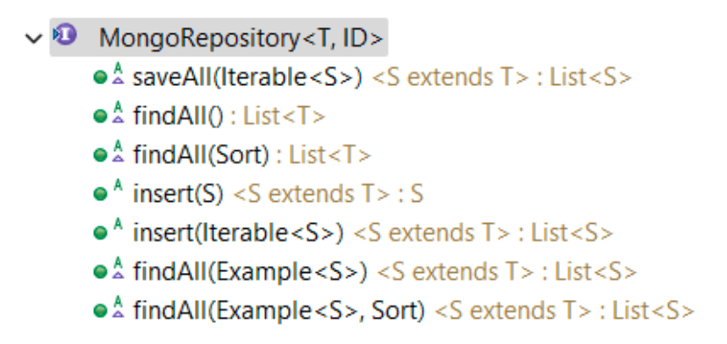

182 SpringBoot MVC, working with embeded server, Behind the scenes of internalViewResolver,HandlerMapping and @Controller,@RequestMapping

SpringBoot-MVC
===============
PreRequisite :: CoreJava + SpringCore + SpringDataJPA(JDBC,Hibernate) +
Servlet,JSP,JSTL(basics knowledge)
Different ways of Developing Java Based WebApplications
=======================================================
Model1Architecture
=> In this architecture either servlet or jsp components is used as main
components of webapplication
=> If servlet component is used, then jsp won't be used or vice-versa.
=> Here each main component contains multiple logics, ie no clear cut
seperation b/w logics.
=> It is not suitable for large scale applications.
Model2Architecture
=> MVC1 Architecture, MVC2 Architecture
=> Here we take support of multiple technologies in multiple layers to develop
the logics.
=> Suitable for Medium and Large scale applications.
=> M(model) V(view) C(Controller)
=> MVC2 Architecture is more industry standard.
=> All Webframeworks like Struts,JSF,Spring-MVC,Spring-Boot-MVC etc are given
based on MVC2 Architecture.
=> MVC means MVC2-Architecture only.
=> MVC3,MVC4,MVC5,MVC6 are no way related to java architecture, therse are
version of asp.net mvc
What is the difference b/w MVC1 and MVC2 Architecture?
=> In MVC1 we take single component(Servlet/jsp) acting as both view and
controller,but we take seperate components for other layers.
=> In MVC2 we take seperate component for View(jsp), seperate Component for
Controller(servlet) and seperate Componet for Model layer.
refer: Spring_mvc_01.png
W.r.t diagram
=============
1. Browser gives the request
2. Controller servlet traps and takes the request[Depending on the url pattern]
3. Using Navigation logic the Controller-Servlet passes the request to appropriate
components(Service,DAO)
4. The service,DAO component process the request.
5. DAO component interacts with Backend system(DB S/W) through model
6. The result generated will be transferred to Service and then it will be forwared
to controller.
7. The controller component passes the result to view component.
8. View component formats the result using Presentation logic.
9,10. The formatted results goes to browser as the response.
MVC2 Architecture pros and cons
===============================
Pros
a. Since there are mulitple layers in application layers we can say there is a
clear cut seperation b/w logics.
b. The modification done in one layer does not affect the other layers.
c. Maintainence and Enchancement of the project becomes easy.
d. Parallel development is possible so productivity is good.
e. It is industry standard architecture to develop java based medium scale and
large scale websites.Cons
a. Since there is a parallel development we need more programmers.
b. Knowledge of multiple technologies is required.
MVC2 architecture rules or principles
=====================================
=> It is not just working with multiple technologies in mulitple layers, there
are set of rules we need to follow
a. Each layer is given to place bunch of logics, just place only such logics,
don't add anyother logics.
b. There can be multiple view comps, multiple model comps,But it is
recomended to take Single controller component.
c. All the operations must take place under the control of Controller
component.
d. View components must not interact with model component directly or
viceversa,they must interact with servlet component.
When we have MVC2 architecture to develop webapplications as layered applications,
what is the need of webapplication frameworks in java?
=> If we develop MVC2 architecture manually by using servlet,jsp technolgies then
a.Programmer should develop all the logics manually
b.Programmer should take care of navigation management
c.Programmer should take care of view management
d.Programmer should take care of data management.
e.Should remember and implement MVC2 rules
f.Chances of having boiler plate code.
To overcome the above limitations and to provide abstration over jee technologies
in webapplication development we can take the support of
MVC2 framework or java webapplication frameworks they are
a. struts -> from apache
b. JSF -> from SUNMS
c. Webwork -> from opensympohny
d. SpringMVC/SpringBoot MVC -> from interface21/pivotal team
e. ADF -> from Oracle corportation
Advantages of developing MVC2 architecture based webapplication development using
webapplication framework
a. Gives ready made Controller-Servlet,no need to write controller logics
manually.
b. Automatically implements maximum of MVC2 Rules
c. The ready made controller servlet can trap all or multiple request to
apply common system services like auditing,logging,security etc
note: ready made servlet will be given based on "FrontController" design
pattern, so it is called as "FrontControllerServlet".
d. FrontControllerServlet takes care of navigation management
e. FrontControllerServlet takes care of view management
f. FrontControllerServlet takes care of data management.
g. Lots of boiler plate code will be avoided.
Note: In Struts, the FrontControllerServlet name is "ActionServlet".
In JSF, the FrontControllerServlet name is "FacesServlet".
In SpringMVC, the FrontControllerServlet name is "DispatcherServlet".
IS MVC1,MVC2 and Model1 are they design patterns or architecutre?
=> These are architecure to develop the java based applications.What is the difference b/w Architectrue and Design pattern?
=> Architecture speaks about involving multiple components and their flow
exeuction in the application development.
=> Design patterns speaks about the best solution for recurring problems in the
application development.
=> In the implementation of Architecture multiple design patterns will be used
eg: MVC2 Architecture speaks about how to involve multiple components in layered
web application development.
In each layer multiple Design patterns will be used to solve the commonly
recurring problems
Contoller layer :: FrontController,ApplicationController,Intercepting
filter etc ,design patterns will be applied.
View layer :: View Helper,CompositeView, .. design patterns will
be applied.
Model layer design pattern will be applied.
:: Service Delegate/Buisness Delegate, DAO and etc
What is FrontController Servlet?
=> The special web component/servlet component of MVC2 Architecture of java based
webapplication who can trap either all request or multiple
requests to apply common system services like auditing,logging,security etc and
also takes care of navigation management, view management
model/data management is caleld "FrontController Servlet".
Navigation Management => Decides the flow among Components.
View Management => Decides Which model/service/handler class results should
go to which view component(jsp or other component)
Data/model Management => Talks about how to store input values(form data) and how
to pass the generated results to various components keeping
them in particular scope.
=> Once the front controller is involved in MVC2 Architecture webapplication,there
will be only one servlet in the entire webapplication that is
FrontController servlet.
=> We keep java classes as "Handler/Controller/Action" classes in webapplications
either to process the request directly or to delegate the
request to service class by taking from FrontController-Servlet.
Note:
a. FrontController is only Servlet Component.
b. Handler/Controller/DAO classes are plain java classes.
c. View components are generally JSP/html/Thymleaf etc...
refer:: Spring_mvc_01.png
Note:
With respect to diagram
a. To make front controller servlet trapping multiple requests take the
support of extension match or directory match url pattern
eg::Extension Match :: *.do, *.ineuron, *.all,....
eg::Directory Match :: /x/y/* , /abc/ijk/*,
/nitin/ineuron/*
b. To make front controller servlet trapping all the request take the
support of "/".
What is the difference b/w FrontController and Controller/Handler/Action classes in
MVC2Architecture and FrontController Design Pattern?FrontController
=> It is a web component(generally it is a servlet/filter web
component)
=> Traps either all request/multiple requests and applies common System
Services.
=> Generally managed by Servlet Container.
=> Gets request,response object that are created and given by Servlet
Container.
=> The main method containing logics are servlet life cycle methods or
convinence methods like doXXXX(,,)
=> Genernally it is one per entire MVC application.
Controller/Handler/Action
=> It is a java class(Spring bean in SpringMVC)
=> Either directly contains request processing logics or contains
logics to delegate request to service class.
=> Managed by JVM of WEbServer(normal webapplication), In case of
SpringMVC webapplication it is managed by IOC Container.
=> Gets request,response object that are passed by FrontController
=> Normally have methods that contains buisness logic or delegation
logic are called "handler" methods.
=> Generally it is one per module.
Note:
=> In SpringMVC/SpringBoot-MVC the FrontController is "DispatcherServlet" which is
ready made ServletComponent.
=> Every Servlet Component(Either Pre-defined/readymade/user-defined)must be
configured with Servlet Container and also must be linked
with url pattern(either with "/" or with "directory/extension" match
urlpattern).
3 ways of Servlet Configuration with Servlet Container
======================================================
1. Declarative approach
=> It is done by using web.xml file
=> if the servlet component is ready made and xml config are allowed in
apps.
eg:: DispatcherServlet configuration in XML driven
SpringMVC apps and in XML + Annotation apps.
<web-app>
<servlet>
<servlet-name>dispatcher</servlet-name>
<servlet-class>org.springframework.web.servlet.DispatcherServlet</
servlet-class>
<init-param>
<param-name>contextConfigLocation</param-name>
<param-value>/WEB-INF/dispatcher-servlet.xml</param-value>
</init-param>
<load-on-startup>1</load-on-startup>
</servlet>
<!-- Set up URL mapping for Spring MVC Dispatcher Servlet -->
<servlet-mapping>
<servlet-name>dispatcher</servlet-name>
<url-pattern>/</url-pattern>
</servlet-mapping>
</web-app>2. Annotation driven approach
=> It is done by using @WebServlet
=> If the servlet component is userdefined then we can configure in
annotation drive approach
eg: Building webapplication using Model1,MVC1,MVC2
and having FrontController in those applications.
@Configuration
@ComponentScan({ "in.ineuron.web" })
public class MVCconfig extends WebMvcConfigurerAdapter {
}
import
org.springframework.web.servlet.support.AbstractAnnotationConfigDispatcherServletIn
itializer;
public class WebInitializer extends
AbstractAnnotationConfigDispatcherServletInitializer {
@Override
protected Class<?>[] getRootConfigClasses()
{
// TODO Auto-generated method stub
return null;
}
@Override
{
protected Class<?>[] getServletConfigClasses()
// TODO Auto-generated method stub
return new Class[] { MVCconfig.class };
}
@Override
protected String[] getServletMappings()
{
// TODO Auto-generated method stub
return new String[] { "/" };
}
}
3.Programmatic approach
=> It is done using ServletContext.addServlet("") method
=> It is useful to configure PreDefined/Readymade servlet Component in
webapplication where xml configuration are not allowed.
eg: In 100%code driven SpringMVC apps,In SpringBoot
MVC apps xml configuration are not allowed, so to configure
DispatcherServlet Component this programmatic
approach will be used either directly or indirectly.
Different approaches to develop SpringMVC applications
======================================================
1. Declartive Cfgs Approach(XML driven cfgs) ======> web.xml file we configure
DispatcherServlet
2. Annotation Cfgs Approach(XML + Annotation driven cfgs) ====> In useredefined
class, with @Configuration set we configure "DispatcherServlet"
3. 100%code driven configuration4. SpringBoot MVC appps
Note::
=> In 1st,2nd approach DispatcherServlet will be configured using web.xml
=> In 3rd,4th approach DispatcherServlet will be configured using
Programatic/DynamicApproach
=> The source code of DispatcherServlet doesn't contains @WebServlet Annotation.
=> All SpringMVC/SpringBootMVC applications that are developed in different
approaches are based on MVC2Architecture and
FrontController(Dispatcher Servlet) design pattern.
While building SpringMVC/SpringBootMVC applications we need to use the following
annotations while developing handler classes
a. @Controller => To make java class as SpringBean + handler/controller
class
b. @RequestMapping => To mark java method of @Controller class as handler
method having requestpath and request mode/method(POST/GET)
Note: As of now browser can send only 2 types
of request[GET(default)/POST]
eg#1.
@Controller
public class LoginController{
@RequestMapping(value="/login" method =RequestMethod.GET)
public String login(parameters...){
//logic for validation or logic to delegate the request to
service class
}
}
The possible parameters for Handler method arguments are
a. javax.servlet.ServletRequest
b. javax.servlet.ServletResponse
c. @PathVariable
d. @RequestParam
e. @RequestHeader
f. @RequestAttribute
g. @ModelAttribute
h. Errors,BindingResult
i. @SessionAttribute
The possible return types of Handler methods
a. String
b. View
c. Model
d. @ModelAttribute
e. ModelAndView
f. void
SpringBoot MVC Flow/Spring MVC Flow
===================================
=> It is designed around Dispatcher Servlet which is predefined FrontController
Servlet Component.
=> All the activities in SpringMVC takes place under the control or monitoring of
DispatcherServlet Component.
Note:
=> DispatcherServlet takes the support of HandlerMapping Component to link thegiven request with Handler method of Controller class.
DispatcherServlet gives Requestpath and RequestMode to HandlerMapping Component
and gets the RequestMappingInfo object having
Controller class beanid and HandlerMethod signature.
=> DispatcherServlet takes the support of ViewResolver Component to map the given
request related results to one of View Component
and gets View Object having physical view component name and location.
=> In SpringMVC View component is Abstract Entity ie we can take any things in
view component like jsp/html/freemarker,velocity components.
refer:: Spring-mvc-01.png
Note::
EmbededEnvironment
==================
Application---> Started =======> JRE,TomcatContainer(virtual)
|
Stopped <======= JRE(removed) TomcatContainer(removed)
W.r.t Diagram
=============
1. Programmer deploys SpringMVC/SpringBootMVC application in webserver or webapps.
2. Deployment activities takes place which involves IOC container
creation ,DispatcherServlet registration with ServletContainer
Pre-Instantiation of Singleton scope spring beans like Controller
class,handlermapping,viewResolvers,Service class,DAO class etc.
In the mean time necessary dependancy injection also takes place.
3. Browser gives request to deployed springmvc application.
4. The frontcontroller(DispatcherServlet) traps the request and applies the common
system services on the request
like logging,auditing,tracking etc,...
5. DispatcherServlet hands over the request to HandlerMapping component to map
incoming request with handler method of handler/controller
class and gets RequestMapping object from HandlerMapping component having
Controller class bean id and HandlerMethod signature(it uses lot
of reflection api code internally).
6. DispatcherServlet takes controller bean class id from the recieved
RequestMapping object and gets the Controller class object from
DispatcherServlet created IOC container.DispatcherServlet also prepares the
necessary objects based on the method signature of the
handled method collected from RequestMapping Info object.
7. DispatcherServlet calls handler method having necessary object as the arguments
on the above received Controller class object.
8. The handler method of the controller class either directly process the request
or takes the support of service/DAO and keeps the result
in a scope(prefereablly in request scope)
9. The handler method of Controller class returns LVN(logical view name) back to
Dispatcher Servlet.
10. DispatcherSerlvet gives LVN to ViewResolver
11. ViewResolver map/link LVN to PhysicalView component and returns View Object
having PhysicalViewName and location.
12. DispatcherServlet gets PhysicalViewName and location from the recieved View
Object and send the control to Physical view component
using rd.forward(,) to format the results gathered from particular
scope(preferabley request scope) using presentation logics.
These formatted results goes back to DispatcherServlet.
13. DispatcherServlet sends the formatted result to browser as the response.HandlerMapping
==============
=> This component takes the incoming request through DispatcherServlet and maps
the request with appropriate handler method of appropriate
handler/controller class by matching the incoming url path with handler request
method path using reflection api and returns
"RequestMappingInfo" object back to DispatcherServlet having the mapped
controller class bean id and handlerMethod signature.
=> All HandlerMapping comps are the classes implementing
org.springframework.web.servlet.HandlerMapping(I)
=> Generally we work with ready made "HandlerMapping" components
a. BeanNamedUrlHandlerMapping[Default in XML driven configuration]
b. RequestMappingHandlerMapping[Default in annotation driven
configuration,100%code driven configuration,SpringBootMVC]
c. ControllerClassHandlerMapping
d. SimpleUrlHandlerMapping
etc...
<beans>
<bean id="handlerMapping"
class="org.springframework.web.servlet.handler.BeanNameUrlHandlerMapping"/>
<beans>
ViewResolver
============
=> This componet takes the recieve logicalViewName with physical view component
returns View Object having the name and location of physical
view component back to dispatcher servlet.
=> It can collects the inputs either in the form of xml file(XMl driven
configuration) or from properties file(SpringBoot App)
=> ViewResolver Components are the classes that implements an interface called
"org.springframework.web.servlet.ViewResolver(I)"
=> Generally we work with ready made "ViewResolver" components
a. UrlBasedViewResolver
b. InternalResourceViewResolver(default in SpringBootMVC)
c. ResourceBundleViewResolver
d. XmlViewResolver
e. TilesViewResolver
f. FreeMarkerViewResolver
g. BeanNameViewResolver
Note: No default ViewResolver in xml,annotationdriver and
100%drivenconfiguration
<bean class="org.springframework.web.servlet.view.InternalResourceViewResolver">
<property name="prefix">
<value>/WEB-INF/</value>
</property>
<property name="suffix">
<value>.jsp</value>
</property>
</bean>
=> InternalViewResolver is capable of taking jsp,html,servlet component placed in
private area of view component through html,jsp components
are not configured in "urlpatttern".
=> In SpringMVC,SpringBootMVC we generally take "jsp" comps as the view componentand it is even recomeneded to keep those jsp components in
"private" area.
Note: Outside of WEB-INF area is called public area of webapplication,the request
to these components can be given directly without giving
mapping details to ServletContainer.
Inside WEB-INF area is called private area of webapplication, the request to
private are components must be given only after giving
mapping details to ServletContainer.
Advantages of placing jsp components in private area
====================================================
=> Helps to hide technology of the webapplication becoz the jsp files names does
not appear in the request urls,so many things does not
appear in the browser address bars.This helps to protect apps from hackers and
jackers.
=> Protects the source code of the jsp components from outsiders
=> If the jsp component is developed to display request scope data given by
servlet component, then direct request to jsp component by
by keeping jsp in public area may give null values or ugly values.[so to stop
that place jsp comp in private area]
refer:: spring-mvc_01.png
=> In our SpringMVC/SpringBoot-MVC keeps jsp component in private area like [WEB-
INF\pages] then InternalResourceViewResolver needs 3 details
to locate these jsp components.
a. Location of jsp components as the prefix info
b. suffix of jsp components
c. jsp filename as the LVN
application.properties
======================
spring.mvc.view.prefix =/WEB-INF/pages/ #location of view
spring.mvc.view.suffix = .jsp #Extension of Technology
Note: In SpringBoot-MVC Apps the following components comes automatically so we
need not develop them
a. DispatcherServlet
b. IOC-Container
c. HandlerMapping
d. ViewResolver
To get all these we need to go for a starter file called "spring-
boot-starter-web".
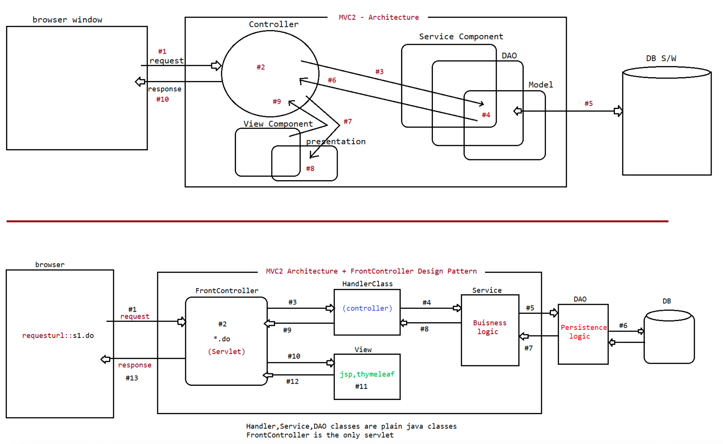
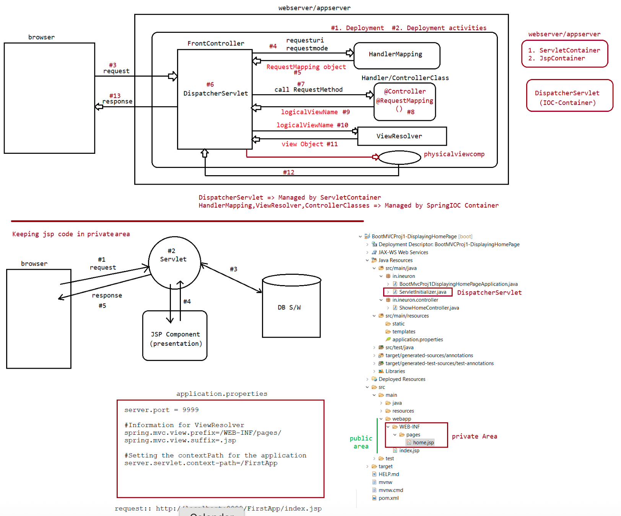

183 springboot MVC examples, working with RequestPath and working with Controller methods

Control Flow of SpringBootMVC
============================
1. Programmer deploys SpringMVC/SpringBootMVC application in webserver or webapps
2. Deployment activities takes place which involves IOC container
creation,DispatcherServlet registration with ServletContainer
Pre-Instantiation of Singleton scope spring beans like Controller
class,handlermapping,viewResolvers,Service class,DAO class etc.
In the mean time necessary dependancy injection also takes place
3. Browser gives request to deployed springmvc application
4. The frontcontroller(DispatcherServlet) traps the request and applies the common
system services on the request
like logging,auditing,tracking etc,...
5. DispatcherServlet hands over the request to HandlerMapping component to map
incoming request with handler method of handler/controller
class and gets RequestMapping object from HandlerMapping component having
Controller class bean id and HandlerMethod signature(it uses lot
of reflection api code internally)
6. DispatcherServlet takes controller bean class id from the recieved
RequestMapping object and gets the Controller class object from
DispatcherServlet created IOC container.DispatcherServlet also prepares the
necessary objects based on the method signature of the
handled method collected from RequestMapping Info object.
7. DispatcherServlet calls handler method having necessary object as the arguments
on the above received Controller class object.
8. The handler method of the controller class either directly process the request
or takes the support of service/DAO and keeps the result
in a scope(prefereablly in request scope)
9. The handler method of Controller class returns LVN(logical view name) back to
Dispatcher Servlet.
10. DispatcherSerlvet gives LVN to ViewResolver
11. ViewResolver map/link LVN to PhysicalView component and returns View Object
having PhysicalViewName and location.
12. DispatcherServlet gets PhysicalViewName and location from the recieved View
Object and send the control to Physical view component
using rd.forward(,) to format the results gathered from particular
scope(preferabley request scope) using presentation logics.
These formatted results goes back to DispatcherServlet.
13. DispatcherServlet sends the formatted result to browser as the response.
Keypoints about SpringBootMVC application
=========================================
=> SpringBoot MVC can be developed as Standalone webapp or deployable
webapplication in webserver/Application Server.
=> SpringBoot MVC Standalone web application means nothing but webapplication that
uses "tomcat embeded server" so no need of arranging
any external server explicitly[Good in development,testing environment]
=> This application comes as a jar file,here SpringApplication.run() itself creates
tomcat embeded server along with IOC container creation
and DispatcherServlet Registration, no need of sepearte ServletInitializer
class.
=> SpringBootMVC deployable webapplication is nothing but webapplication that is
deployable in any webserver as normal war file.
=> Here Seperate ServletInitializer class is required extending from
SpringBootServlet Initializer to create IOCcontainer and register
DispatcherServlet dynamically.
=> In both the cases IOC container created is
"AnnotationConfigWebApplicationContext".Note:: While creating Spring-boot-mvc project if we select the type as "war", then
the starter files will create 2 java files
a. Main class cum Configuration class having @SpringBootApplication
=> The main() class is not required if we are running our
App as Deployable webapplication using External
Tomcatserver/any other server
b. ServletInitializer extending SpringBootServletInitializer
=> This class is not required if we are running our
application as standalone webapplication using embeded server.
BootMVCProj1-DisplayingHomePage
|=> src/main/java
|=> in.ineuron
|=>
BootMvcProj1DisplayingHomePageApplication(@SpringBootApplication)
|=> ServletInitializer(extends
SpringBootServletInitializer)
Note: If we run springboot application as standalone app,then the
SpringApplication.run() method takes care of multiple activities like
a. Creating an Embeded tomcat server
b. Creating an IOC container
c. Creating an DispatcherServlet having IOC-container
d. Creating an ErrorFilter classes objects
e. Registering DispatcherServlet,ErrorFilters dynamically with Servlet
Container
so on.....
=> By default SpringBootMVC Apps runs without ContextPath, To provide ContextPath
for those Apps we need to add one special entry in application.properties
application.properties
======================
server.servlet.context-path=/FirstApp
spring.mvc.view.prefix = /WEB-INF/pages
spring.mvc.view.suffix = .jsp
server.port = 9999
old url :: http://localhost:9999/index.jsp
new url :: http://localhost:9999/FirstApp/index.jsp
Note: Embeded tomcat server is not taking index.jsp as the default welcome file,
but external tomcat server will take
Only standalone execution of springbootmvc app takes the cfg "ContextPath"
from application.properites file
The deployable webapplication execution in external server takes the project
name as the "ContextPath".
If we are running SpringBootMVC app as a deployable app in external server,
then we can comment main() of @SpringBootApplication class
If we are running SpringBootMVC app as a standalone app using embeded server
then we can remove "ServletInitalizer" class.
In order to get welcomepage/home page of the spring mvc app without typing
index.jsp in the browser address(stanadlone webapp) or to avoid index.jsp,we need
to take the handler method that give LVN of home page having request path="/".
eg::
@Controllerpublic class ShowHomeController {
@RequestMapping(value = "/", method = RequestMethod.GET)
public String showHomePage() {
return "home"; //WEB-INF/pages/home.jsp[delete index.jsp avaialble in
public area]
}
}
request url:: http://localhost:9999/FirstApp/
output:: Welcome to SpringMVC
Working with Handler Methods
============================
=> If the handlerMapping method return type is "String" then it returns only "LVN"
to dispatcher Servlet.
=> If the handlerMapping method return type is "ModelAndView" then it return
"Model Attributes" and "LogicalViewName" to DispatcherServlet.
=> If the DispatcherServlet receives ModelAndView Class Object from the Handler
method then it makes the model attribute
as the request scope data and it gives the recieved LVN to ViewResolver.
=> Taking ModelAndView is a legacy approach, go for alternative.
application.properties
======================
server.port=9999
spring.mvc.view.prefix=/WEB-INF/pages/
spring.mvc.view.suffix=.jsp
server.servlet.context-path=/SecondApp
eg#1.
@RequestMapping(value="/",method = RequestMethod.GET)
public String showHome() {
return "home";//WEB-INF/pages/home.jsp
}
Usage of ModelAndView
=====================
@RequestMapping(value = "/wish",method = RequestMethod.GET)
public ModelAndView generateMessage() {
String msg = service.generateWishMessage();
ModelAndView mav = new ModelAndView();
mav.addObject("wmg", msg);
mav.setViewName("display");// WEB-INF/pages/display.jsp
return mav;
}
request url:: http://localhost:9999/SecondApp/
Usage of Model(I)
================
@RequestMapping(value = "/wish", method = RequestMethod.GET)
public String generateMessage(Model model) {
System.out.println("SharedMemory object class name is :: " +
model.getClass().getName());
String msg = service.generateWishMessage();
model.addAttribute("wmg",msg);
return "display"; //WEB-INF/pages/display.jsp}
Usage of Map<String,Object>[BestApproach as it is Non-Invasive]
===============================================================
@RequestMapping(value = "/wish", method = RequestMethod.GET)
public String generateMessage(Map<String,Object> model) {
System.out.println("SharedMemory object class name is :: " +
model.getClass().getName());
String msg = service.generateWishMessage();
model.put("wmg",msg);
return "display";
}
Making the return type as void
==============================
@RequestMapping(value = "/wish", method = RequestMethod.GET)
public void generateMessage(Map<String, Object> model) {
System.out.println("SharedMemory object class name is :: " +
model.getClass().getName());
String msg = service.generateWishMessage();
model.put("wmg", msg);//WEB-INF/pages/wish.jsp
}
If the handler method return type is void,it takes the incoming request path as
excluding("/") as LVN by using "RequestToViewNameTranslator"
concept internally.
eg:: incoming reuqest is "/wish", then it takes "wish" as LVN.
Behind the scenes
=================
=> DispatcherServlet creates one SharedMemory called "BindingAwareModelMap" object
to maintain model attributes having request scope.
=> By exposing this BindingAwareModelMap objects to handler methods as a parameter
we can add model data attributes to it
(default scope is request)
=> All view components belonging to same request scope can read and use model
attributes data.
Note: If we are using InternalResourceViewResolver in SpringMVC applications, then
all the view components must be in the same location
(prefix) and in same technology(suffix).
To keep different view comps in different locations and in different
technologies take the support of Multiple view resolvers.
Sending the response directly to the browser without using DispatcherServlet
============================================================================
@RequestMapping(value="/wish", method = RequestMethod.GET)
public void generateWishMessage(HttpServletResponse response) throws Excpetion{
String msg = service.generateWishMessage();
PrintWriter out = response.getWriter();
response.setContentType("text/html");
pw.println("<b>WishMessage is :: "+msg+"</b>");
return ;
}@RequestMapping(value="/wish", method = RequestMethod.GET)
public String generateWishMessage(HttpServletResponse response) throws Excpetion{
String msg = service.generateWishMessage();
PrintWriter out = response.getWriter();
response.setContentType("text/html");
pw.println("<b>WishMessage is :: "+msg+"</b>");
return null;
}
These type of handler methods are so useful when we perform "FileDownloading"
activities.
eg::
@RequestMapping(value="/wish", method = RequestMethod.GET)
public Model generateWishMessage(){
String msg = service.generateWishMessage();
Model model = new ExtendedModelMap();
model.addAttribute("wmg",msg);
return model;
}
Taking Model as the return type of HandlerMethod is a bad practise,because of the
following reasons
a. We should know the process of Creation Model object explicitly
b. Internally created SharedMemory(BindingAwareModelMap) will be wasted
c. There is no control on LVN, we are forced to take the request uri as the
logical name.
Taking Model as the parameter of the HandlerMethod is a good practise,because of
the following reasons
a. Full Control of LVN.
b. Creating BindingAwareModelMap object as the sharedmemory is taken care by
DispatcherServlet
c. Creating parameter type reference variable pointing to the sharedmemory is
also taken care by DispatcherServlet.
d. Internally created SharedMemory(BindingAwareModelMap) will not be wasted.
e. Taking Parameter type as HashMap or Map we make Handler methods as "Non-
Invasive".
We need to consider the following points while giving requestpath to handler
methods of Controller class
===================================================================================
======================
a. The request path of handler method must start with "/".
b. The request path of handler method is caseSensitive.
eg::
@Controller
public class TestController{
@RequestMapping(value= "/REPORT)
public String showReport(Map<String,Object> map){
;;;;
}
@RequestMapping(value= "/report)
public String showReport1(Map<String,Object> map){
;;;;;}
}
requestURL :: http://localhost:9999/ThirdApp/REPORT ===> showReport()
requestURL :: http://localhost:9999/ThirdApp/report ===> showReport1()
c. Multiple request have same request path with different request methods like
POST/GET
@Controller
public class TestController {
@GetMapping
public String showHome() {
System.out.println("TestController.showHome()");
return "home";
}
@RequestMapping(value="/report",method = RequestMethod.GET)
public String showReport(Map<String,Object> map) {
System.out.println("TestController.showReport(-)");
return "display";
}
@RequestMapping(value="/report",method = RequestMethod.POST)
public String showReport1(Map<String,Object> map) {
System.out.println("TestController.showReport1(-)");
return "display1";
}
}
home.jsp
========
<%@ page isELIgnored="false" %>
<!--POST REQUEST-->
<form action="report" method="POST">
<input type="submit" value="send"/>
</form>
<br>
<a href="report">link1</a> <!--GET REQUEST-->
display1.jsp
============
<h1 style="color:red;text-align:center"> from display1.jsp </h1>
display.jsp
===========
<h1 style="color:red;text-align:center"> from display.jsp </h1>
Note:: Instead of using @RequestMapping by specifiying requestmode GET/POST we can
directly use "@PostMapping" and "GetMapping".
d. Taking @RequestMapping without requestpath takes "/" as default path
@GetMapping("/")
public String showHome() {
System.out.println("TestController.showHome()");
return "home";
}
is equal to@GetMapping
public String showHome() {
System.out.println("TestController.showHome()");
return "home";
}
e. One Handler class can have multiple request paths
@GetMapping(value={"/report","/report1","/report2"})
public String showReport(Map<String,Object> map) {
System.out.println("TestController.showReport(-)");
return "display";
}
requestURL :: http://localhost:9999/ThirdApp/report ===> showReport()
requestURL :: http://localhost:9999/ThirdApp/report1 ===> showReport()
requestURL :: http://localhost:9999/ThirdApp/report2 ===> showReport()
f. RequestMapping with Mode should be unique with respect to controller class.
@GetMapping(value={"/report"})
public String showReport(Map<String,Object> map) {
System.out.println("TestController.showReport(-)");
return "display";
}
@GetMapping(value={"/report"})
public String showReport1(Map<String,Object> map) {
System.out.println("TestController.showReport1(-)");
return "display";
}
=======================================================================
@GetMapping
public String showHome() {
System.out.println("TestController.showHome()"); =====> urlPattern :: / and
RequestMode :: GET
return "home";
}
@GetMapping
public String showHome1() {
System.out.println("TestController.showHome()"); =====> urlPattern :: / and
RequestMode :: GET
return "home";
}
===================================================================
g. In SpringMVC max two methods can be taken without requestpath(One with GET
request and another one with POST request)
@PostMapping
public String showHome() {
System.out.println("TestController.showHome()");
return "home";
}
@GetMapping
public String showHome1() {
System.out.println("TestController.showHome1()");
return "home";}
h. If two controller class have two handler methods with same request type and
request mode then we need to differentiate them at the
Controller level using "global request path"
@Controller
public class DemoController {
@GetMapping(value={"/report"})
public String generateReport(Map<String,Object> map) {
return "display";
}
}
@Controller
public class TestController {
@GetMapping(value={"/report"})
public String generateReport(Map<String,Object> map) {
return "display";
}
}
Solution
========
@Controller
@RequestMapping("/demo")//global requestpath
public class DemoController {
@GetMapping(value={"/report"})
public String generateReport(Map<String,Object> map) {
return "display";
}
}
@Controller
@RequestMapping("/test")//global requestpath
public class TestController {
@GetMapping(value={"/report"})
public String generateReport(Map<String,Object> map) {
return "display";
}
}
requestURL :: http://localhost:9999/ThirdApp/demo/report ===>
DemoController.generateReport()
requestURL :: http://localhost:9999/ThirdApp/test/report ===>
TestController.generateReport()
j. We cannot take ServletContext,ServletConfig object as a parameter of handler
method becoz they are global objects which go for
@Autowired injections more over they are not valid parameter types for handler
methods,but we can take HttpSession type
parameter in handler methods.
@Controller
@RequestMapping("/demo")
public class DemoController {
@GetMapping(value={"/report"})
public String generateReport(Map<String,Object> map,HttpSession ses) {
System.out.println("DemoController.generateReport(-)");
System.out.println("Session Id:"+ses.getId());}
}
return "display";
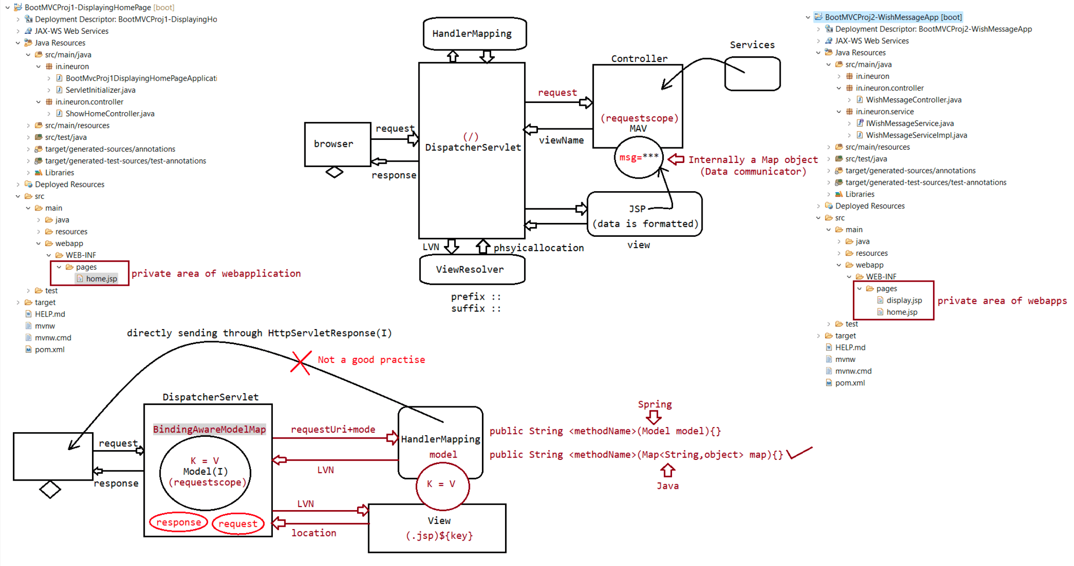

184 SpringMVC[RequestMapping,@ModelAttribute,@RequestParam] ,Databinding[Oneway,Twoway],DataRendering

eg#1.
@Controller
@RequestMapping("/")
public class LoginController{
@GetMapping(value="")
public String <methodName>(Map<String,Object> model,....){
return "";
}
@PostMapping(value="")
public String <methodName>(Map<String,Object> model,....){
return "";
}
}
The possible parameters for Handler method arguments are
a. javax.servlet.ServletRequest
b. javax.servlet.ServletResponse
c. @PathVariable
d. @RequestParam
e. @RequestHeader
f. @RequestAttribute
g. @ModelAttribute
h. Errors,BindingResult
i. @SessionAttribute
The possible return types of Handler methods
a. String
b. View
c. Model
d. @ModelAttribute
e. ModelAndView
f. void
DataBinding and DataRendering
=============================
DataBinding :: The process of writing input values(form data/request parameter
data) to java class object is called "DataBinding".
DataRendering :: The process of giving controller generated/gathered
results/outputs after executing buisness logic to viewcomponents through
SharedMemory (BindingAwareModelMap object) is called
"DataRendering".
Note:
DataBinding => Binding the data from view component to controller in the form of
java class object called Model class object.
DataRendering=> Passing data/results/outputs from Controller to view Component as
ModelAttributes through SharedMemory called
BindingAwareModelMap object.
Passing different types of results/ouputs/data in DataRendering
a. Passing simplevalues
b. Passing array/collectionsc. Passing collection of Model/Buisness Object
d. Passing single Object of Model/Buisness Object/Entity class.
Note: Model(I) comes from SpringFramework, where as Model is Bo/Entity class.
Reading Simple values
=====================
@Controller
public class TestController {
@GetMapping("/report")
public String showReport(Map<String,Object> map) {
System.out.println("TestController.showReport()");
map.put("name", "kohli");
map.put("age", 35);
map.put("address", "RCB");
return "show_report";
}
}
show_report.jsp
===============
<h1 style="color:red; text-align: center;"> READING SIMPLE VALUES</h1>
<b>NAME IS :: ${name}</b><br/>
<b>AGE IS :: ${age}</b><br/>
<b>ADDR IS :: ${address}</b><br/>
Passing arrays and collection values from controller class to view component in
DataRendering process
===================================================================================
==================
package in.ineuron.controller;
import java.util.HashSet;
import java.util.List;
import java.util.Map;
import java.util.Set;
import org.springframework.stereotype.Controller;
import org.springframework.web.bind.annotation.GetMapping;
@Controller
public class TestController {
@GetMapping("/report")
public String showReport(Map<String, Object> map) {
System.out.println("TestController.showReport()");
String nickNames[] = new String[] { "sachin", "saurav", "dravid",
"kohli" };
Set<Long> mobilePhonesSet = new HashSet<Long>();
mobilePhonesSet.add(9999999L);
mobilePhonesSet.add(8888888L);
List<String> coursesList = List.of("java", "spring", "spring boot",
"hibernate");
Map<String, Long> idsMap = Map.of("aadhar", 4543535L, "voterId",
53543543534L, "panNo", 4545355454L);//Creating a ModelAttributes
map.put("nickNames", nickNames);
map.put("phonesInfo", mobilePhonesSet);
map.put("coursesInfo", coursesList);
map.put("idsInfo", idsMap);
return "show_report";
}
}
show_report.jsp
===============
<b>Arrays Data</b>
<br />
<c:forEach var="name" items="${nickNames}">
${name }<br />
</c:forEach>
<hr />
<b>List Data</b>
<br />
<c:forEach var="course" items="${coursesInfo}">
${course }<br />
</c:forEach>
<hr />
<b> Phone number (set)::</b>
<br>
<c:forEach var="phone" items="${phonesInfo}">
${phone} <br>
</c:forEach>
<hr/>
<b> ids Info (Map)::</b>
<br>
<c:forEach var="id" items="${idsInfo}">
${id.key} ===> ${id.value} <br>
</c:forEach>
Passing List of Model class Objects to view component from Controller Using
DataRendering Process
===================================================================================
==============
Employee.java
=============
@Data
@NoArgsConstructor
@AllArgsConstructor
public class Employee {
private Integer eno;
private String ename;
private String desg;
private Double salary;
}
TestController.java
===================@Controller
public class TestController {
@GetMapping("/report")
public String showReport(Map<String, Object> map) {
System.out.println("TestController.showReport()");
List<Employee> empsList = List.of(new Employee(10, "sachin", "batsman",
90000.0),
new Employee(7, "dhoni", "keeper", 190000.0), new
Employee(18, "kohli", "captain", 180000.0));
map.put("empsInfo", empsList);
return "show_report";
}
}
show_report.jsp
===============
<table border="1" align="center">
<tr>
<th>eno</th>
<th>ename</th>
<th>desg</th>
<th>salary</th>
</tr>
<c:forEach var="emp" items="${empsInfo}">
<tr>
<td>${emp.eno}</td>
<td>${emp.ename}</td>
<td>${emp.desg}</td>
<td>${emp.salary}</td>
</tr>
</c:forEach>
</table>
Passing single model class object as a model attribute from controller to view
component in data rendering process
===================================================================================
===============================
Employee.java
=============
@Data
@NoArgsConstructor
@AllArgsConstructor
public class Employee {
private Integer eno;
private String ename;
private String desg;
private Double salary;
}
TestController.java
===================
@Controller
public class TestController {
@GetMapping("/report")
public String showReport(Map<String, Object> map) {
System.out.println("TestController.showReport()");Employee employee = new Employee(10, "sachin", "batsman", 90000.0);
map.put("emp", employee);
return "show_report";
}
}
show_report.jsp
===============
<table border="1" align="center">
<tr>
<th>eno</th>
<th>ename</th>
<th>desg</th>
<th>salary</th>
</tr>
<tr>
<td>${emp.eno}</td>
<td>${emp.ename}</td>
<td>${emp.desg}</td>
<td>${emp.salary}</td>
</tr>
</table>
Conclusion of DataRendering in SpringBootMVC App
================================================
=> It is the process of passing data from controller class handler methods to view
components through DispatcherServlet using Sharedmemory
called "BindingAwareModelMap".
DataBinding
===========
=> It is the process of giving the view comps supplied input values to handler
methods of controller class
View to controller data passing :: Data Binding
Controller to View data passing :: Data Rendering
Binding can be done in 2 ways
=============================
a. Binding form data to handler method of controller class as the Model/Command
class Object using "@ModelAttribute".It is also called as
"FormBinding/RequestWrapping".
b. Binding hyperlink generated additional request param values to handler method
of Handler class using "@RequestParam".It is also called as
"RequestParam Binding".
a. Binding form data to handler method of controller class as the Model object
using "@ModelAttribute".
Model class/JavaBean class
==========================
=> The java bean class whose object holds form component values of form page is
called "Model class".
For form binding/data binding we need to follow the operations
=> Count form components in form page and take same no of properties in Model
class
match.
=> Make sure that form component names and Model class attributes names should=> Add getter and setter methods for the Properties of the Model class
=> Take Handler method in Handler class having @ModelAttribute<model class type>
parameter.
register.jsp
============
<form method="POST">
<table align="center">
<tr><td>Employee number:: </td> <td><input type="text" name="eno">
</td></tr>
<tr><td>Employee name:: </td> <td><input type="text" name="ename">
</td></tr>
<tr><td>Employee address:: </td> <td><input type="text" name="eadd">
</td></tr>
<tr><td>Employee salary:: </td> <td><input type="text" name="salary">
</td></tr>
<tr><td colspan="2"><input type="submit" value="register"> </td> </tr>
</table>
</form>
Employee.java
=============
@Data
public class Employee {
private int eno;
private String ename;
private String eadd="hyd";
private float salary;
public Employee() {
System.out.println("Employee:: 0-param constructor");
}
}
@Controller
public class EmployeeController {
@PostMapping("/emp_register")
public String regiserEmployee(Map<String,Object> map,@ModelAttribute("emp")
Employee emp) {
//read and use form data from model class object or send to service class
System.out.println(emp);
return "result";
}
}
Internal Operations of FormBinding
==================================
1. End user fills up the formpage and submit the request
2. Dispatcher servlet traps and take the request
3. Dispatcher Servlet gets handler method signature through "RequestMappingInfo"
component.
4. Dispatcher Servlet noticies @ModelAttribute("emp") Employee emp type parameter
and it understands to perform Databinding/FormBinding
by taking Employee class as the Model class.
5. Creates a Model class Object having the name given in the @ModelAttribute("emp")
as the object name
Employee emp = new Employee()
Note: If @ModelAttribute is taken without param then it takes the Modelclass name like Employee and create the Object having
class name as the object name with the first letter lowercase.
eg: Employee employee = new Employee();
6. Reads the data using request.getParameter("") and it performs the necessary
conversion according to the Model class properties using
PropertyEditors
7. Writes the received and converted form data to Model class object using setter
methods
8. Dispatcher servlet creates another necessary objects like BindingAwareModelMap
Object and calls handler method having those objects
and Model class object(emp).
Note:
Generally we take two handler methods in Controller class with respect to form page
operation
a. First Handler method in GET Mode to Lanuch Form page.
b. Second Handler method in POST mode to process from page submission request.
For both the handler methods we can take same request path with
different request mode(recomended)
If the above request handler methods are having two different requests
path then the request mode are your choice.
Taking same request path for both handler methods[Form launching and submit request
processing form page]
=> Taking action attribute in <form ..> becomes optional.
=> When form page is launched we take initial data from Model class object
properties and We can display in form page components as
initial values.[It is possible if form page is designed using spring suplied
jsp tags]
EmployeeController.java
=======================
@Controller
public class EmployeeController {
@GetMapping("/")
public String showHome() {
return "home";
}
@GetMapping("/emp_register")
public String showForm() {
return "register";
}
@PostMapping("/emp_register")
public String regiserEmployee(Map<String, Object> map, @ModelAttribute
Employee emp) {
// read and use form data from model class object or send to service
class
System.out.println(emp);
return "result";
}
}
Employee.java
=============
@Data@NoArgsConstructor
@AllArgsConstructor
public class Employee {
private Integer eno;
private String ename;
private String eadd;
private Double salary;
}
home.jsp
========
<h1 style="text-align: center">
<a href="emp_register">Register Employee</a>
</h1>
register.jsp
============
<form method="POST">
<table align="center">
<tr><td>Employee number:: </td> <td><input type="text" name="eno">
</td></tr>
<tr><td>Employee name:: </td> <td><input type="text" name="ename">
</td></tr>
<tr><td>Employee address:: </td> <td><input type="text" name="eadd">
</td></tr>
<tr><td>Employee salary:: </td> <td><input type="text" name="salary">
</td></tr>
<tr><td colspan="2"><input type="submit" value="register"> </td> </tr>
</table>
</form>
</body>
</html>
result.jsp
==========
<center>
<h1 style="color: red; text-align: center">Result page</h1>
<b>form data :: ${employee} </b> <br> <a href="./">home</a>
</center>
If we use HTML Forms, then by default we will have support only for
"OneWayBinding".[Form to Model class Object]
To get the support of TwoWayBinding then we need to go for "SpringMVC jsp
taglibraries".[Form->Model, Model->Form]
SpringMVC taglibrary
===================
1. Generic Taglibrary
2. Form tag library
<%@ taglib prefix="form" uri="http://www.springframework.org/tags" %>
<%@ taglib prefix="form" uri="http://www.springframework.org/tags/form"
%>
refer:: BootMVCPro6-DataBindingAppUsingSpringTagLibrary
<%@ page language="java" contentType="text/html; charset=ISO-8859-1"
pageEncoding="ISO-8859-1" isELIgnored="false"%>Home.jsp
========
<%@ taglib prefix="form" uri="http://www.springframework.org/tags/form"%>
<!DOCTYPE html PUBLIC "-//W3C//DTD HTML 4.01 Transitional//EN"
"http://www.w3.org/TR/html4/loose.dtd">
<html>
<head>
<meta http-equiv="Content-Type" content="text/html; charset=ISO-8859-1">
<title>Home Page</title>
</head>
<body>
<center>
<h1 style="color: red; text-align: center;">Employee Registration
Page</h1>
<form:form method ="POST" modelAttribute="emp">
<table>
<tr>
<th>ENO</th>
<td><form:input path='eno' /></td>
</tr>
<tr>
<th>ENAME</th>
<td><form:input path='ename' /></td>
</tr>
<tr>
<th>EDESG</th>
<td><form:input path='edesg' /></td>
</tr>
<tr>
<th>SALARY</th>
<td><form:input path='salary' /></td>
</tr>
<tr>
<td></td>
<td><input type='submit' value='register'></td>
</tr>
</table>
</form:form>
</center>
</body>
</html>
Employee.java
=============
@Data
public class Employee {
private Integer eno;
private String ename="sachin";
private String edesg;
private Double salary;
}
EmloyeeController.java
======================
@Controller
public class EmployeeController {
@GetMapping("/register")
public String showForm(@ModelAttribute("emp") Employee employee) {return "home";
}
@PostMapping("/register")
public String registerEmployee(Map<String, Object> model,
@ModelAttribute("emp") Employee employee) {
System.out.println("EmployeeController.registerEmployee()");
System.out.println(employee);
model.put("employee", employee);
return "result";
}
}
result.jsp
==========
<%@ page language="java" contentType="text/html; charset=ISO-8859-1"
pageEncoding="ISO-8859-1" isELIgnored="false"%>
<!DOCTYPE html PUBLIC "-//W3C//DTD HTML 4.01 Transitional//EN"
"http://www.w3.org/TR/html4/loose.dtd">
<html>
<head>
<meta http-equiv="Content-Type" content="text/html; charset=ISO-8859-1">
<title>Insert title here</title>
</head>
<body>
<center>
<h1 style='color:red; text-align: center;'>EMPLOYEE DATA</h1>
<table border='1'>
<tr>
<th>ENO</th>
<td>${employee.eno}</td>
</tr>
<tr>
<th>ENAME</th>
<td>${employee.ename}</td>
</tr>
<tr>
<th>EDESG</th>
<td>${employee.edesg}</td>
</tr>
<tr>
<th>SALARY</th>
<td>${employee.salary}</td>
</tr>
</table>
</center>
</body>
</html>
What is the difference b/w HTML Tags vs SpringMVC jsp tags?
HTML tags
=========
a. Supports one way binding(Form -> Model)
b. Given by W3C
c. Defult request method type is "GET"
d. These tags are executed by HTML interpreter
e. Not recomended to use in SpringMVC
SpringMVC jsp tags=================
a. Supports two way binding(Form-> Model,Model-> Form)
b. Given by Pivotal team
c. Default request method type is "POST"
d. JSP tags will be converted to HTML tags having the values collected from Model
object as th initial values
e. Recomended to use in SpringMVC
DataBinding using @RequestParam
===============================
=> The request param in the query string either directly or by using hyperlink can
be bound to handler method params of controller class
by using the support of "@RequestParam" Annotation.
case1::http://localhost:9999/DataBindingApp/data?sno=10
@GetMapping("/data")
public String bindData(Map<String, Object> model, @RequestParam Integer
sno,@RequestParam String sname) {
System.out.println("DataBindingController.bindData()");
System.out.println("SNO is :: "+sno);
System.out.println("SNAME is :: "+sname);
return "show_data";
}
output:: Exception
case2:: http://localhost:9999/DataBindingApp/data?sno=10
@GetMapping("/data")
public String bindData(Map<String, Object> model, @RequestParam Integer
sno,@RequestParam(required = false)String sname) {
System.out.println("DataBindingController.bindData()");
System.out.println("SNO is :: "+sno);
System.out.println("SNAME is :: "+sname);
return "show_data";
}
output:: sno = 10 sname =
case3::http://localhost:9999/DataBindingApp/data?sno=10
@GetMapping("/data")
public String bindData(Map<String, Object> model, @RequestParam Integer
sno,@RequestParam(defaultValue="sachin") String sname) {
System.out.println("DataBindingController.bindData()");
System.out.println("SNO is :: "+sno);
System.out.println("SNAME is :: "+sname);
return "show_data";
}
output : sno = 10 sname=sachin

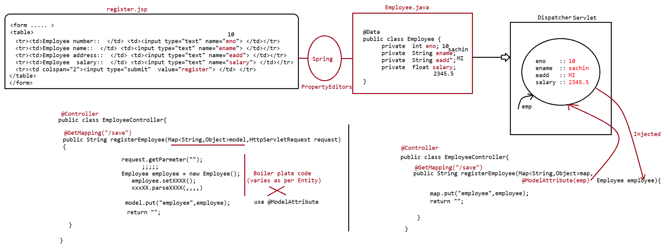
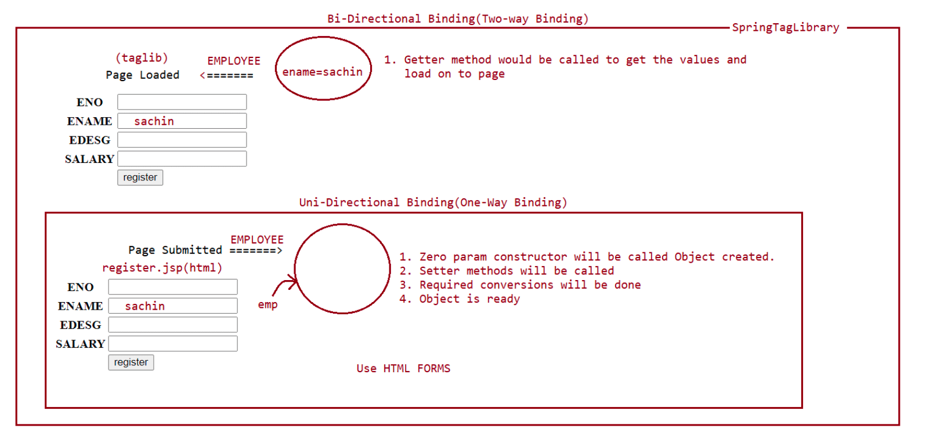
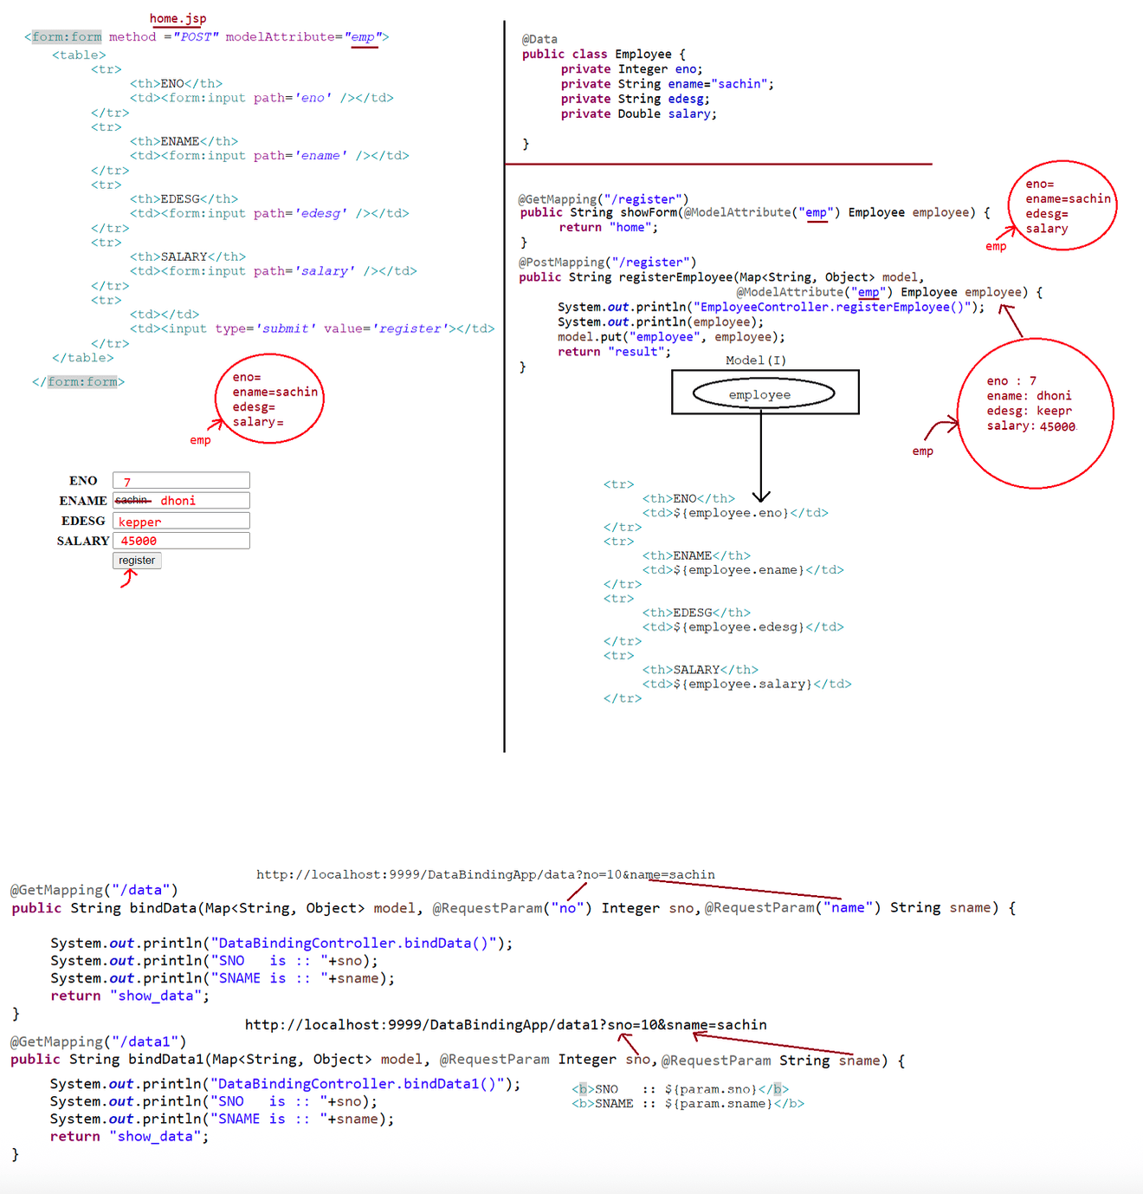

185 SpringBootMVC Project(using JSP,Using Thymleaf and bootstrap)

Technolgies used
================
DispatcherServlet(InbuiltController)
1. Controller(plain java class)
2. Service(plainjava class)
3. DAO(spring-datajpa)
4. View part(Html,Css,JSP)
Customer-RelationShip-Manager Project
=====================================
1.CreateCustomer(save(Customer))
2.ReadAllCustomer(findById(customerId))
3.UpdateCustomer(save(Customer))
4.DeleteCustomer(deleteById(customerId))
(Spring-data-jpa)
Controller=========> Service===========>DAO=====================>Database
Try on our own
==============
=> I18N
=> Pagination
refer:: BootMVCProj8-MVC-CRM-CRUDAPP
Thymeleaf
========
a. In pom.xml add the starter files
<dependency>
<groupId>org.springframework.boot</groupId>
<artifactId>spring-boot-starter-thymeleaf</artifactId>
</dependency>
b. Keep the view components inside src/main/resources/templates
templates
|-> customers
|=> customer-form.html
|=> list-customers.html
c. Keep index.html as the landing page,keep it src/main/resources/static
<meta http-equiv="refresh" content="0; URL='customer/list'" />
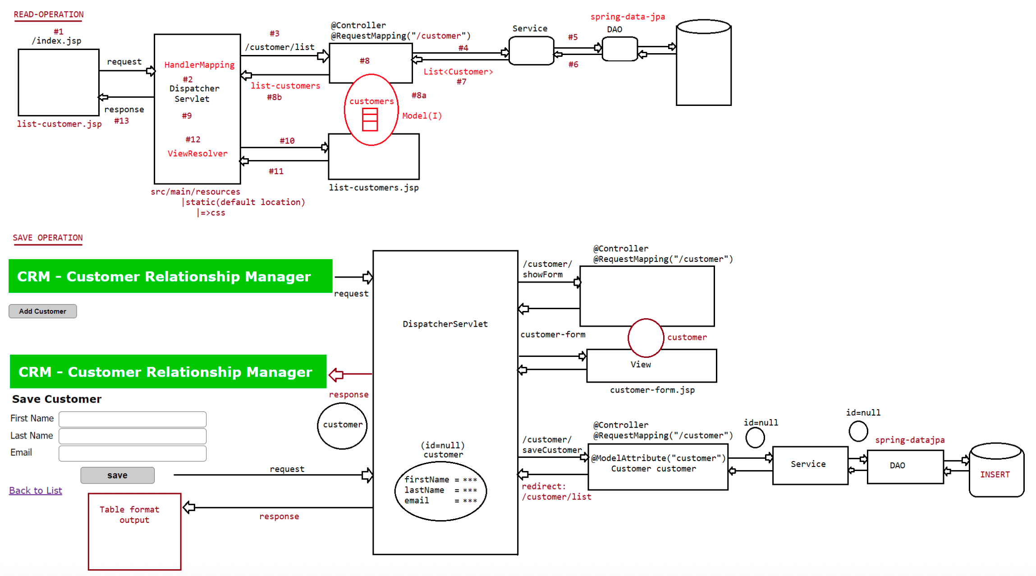
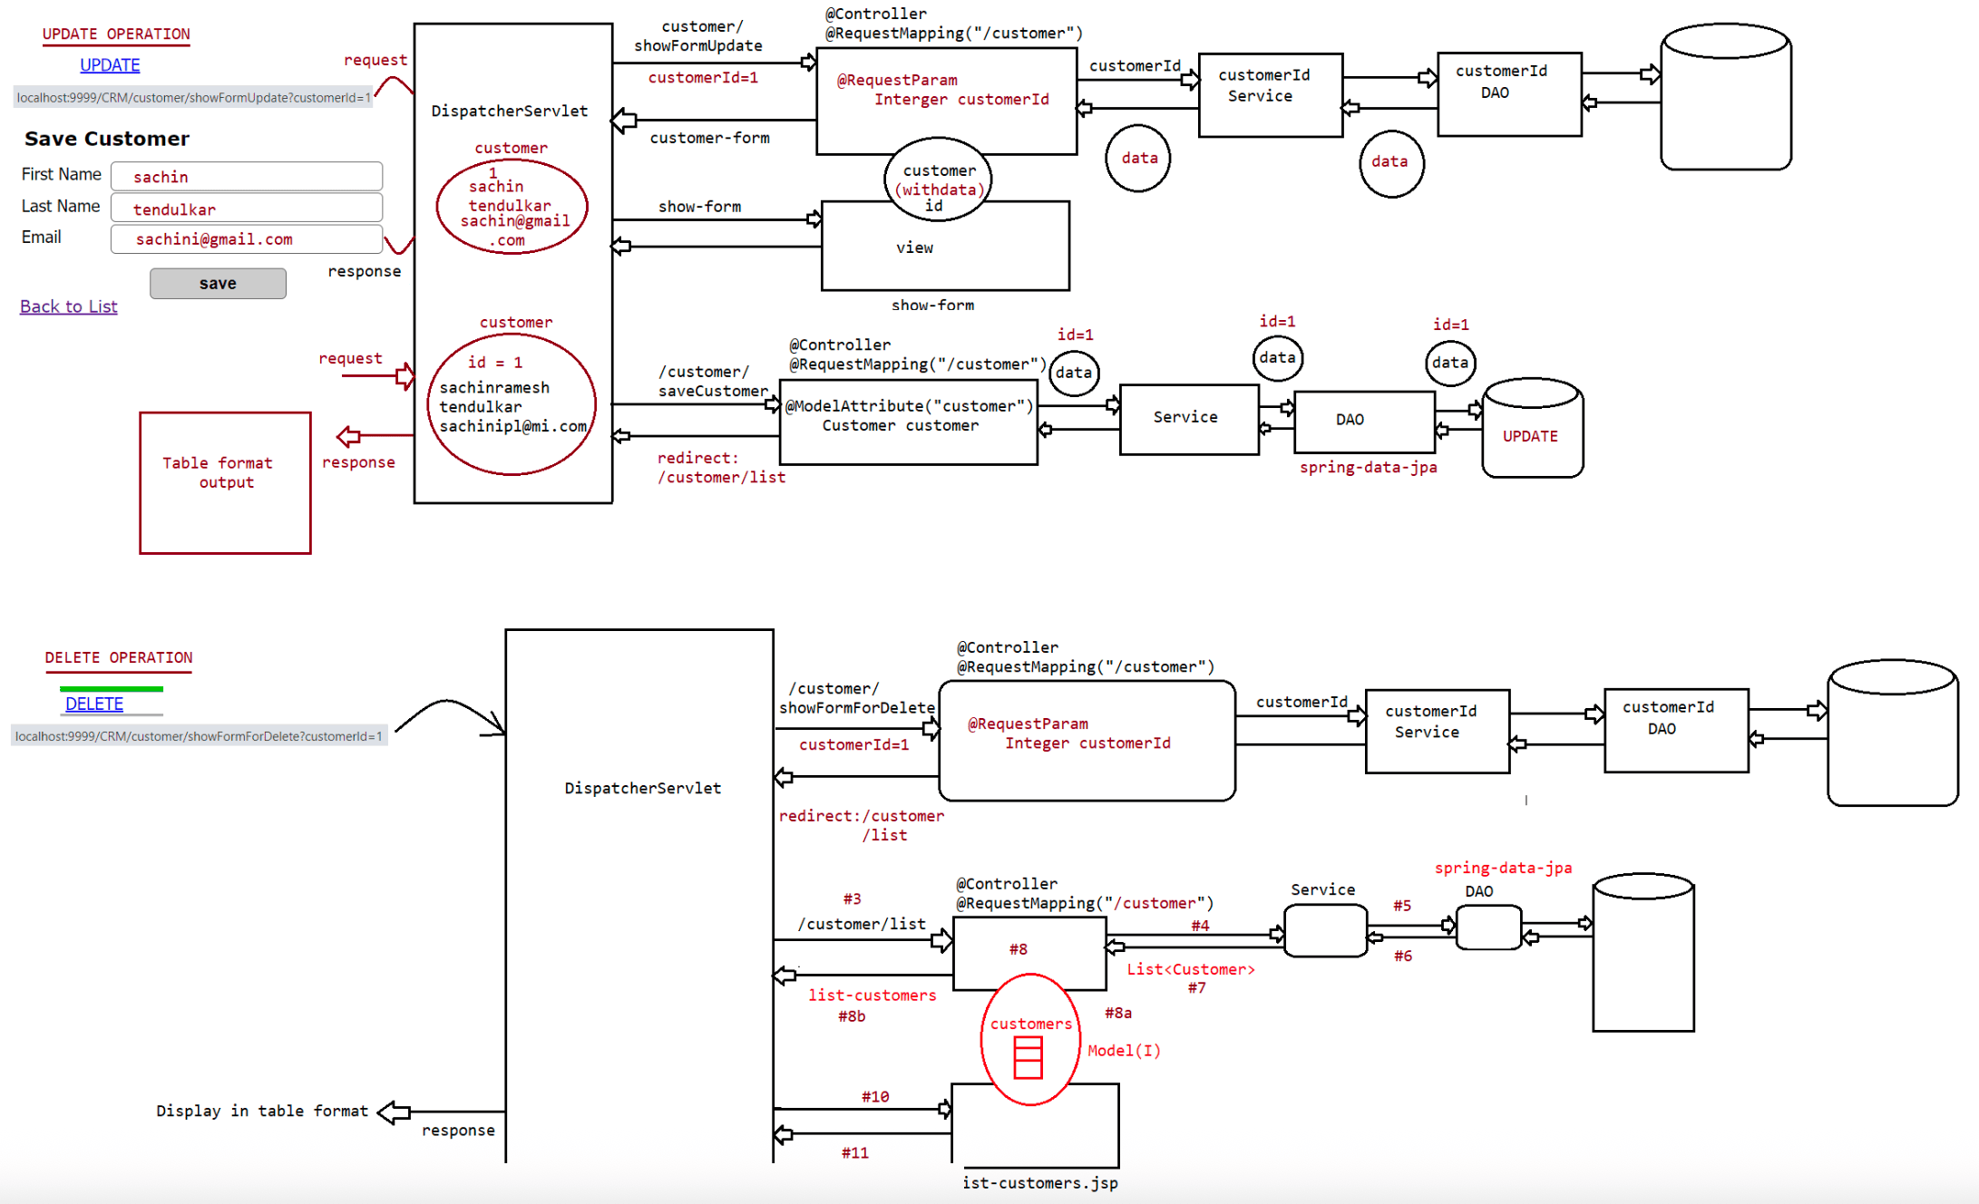
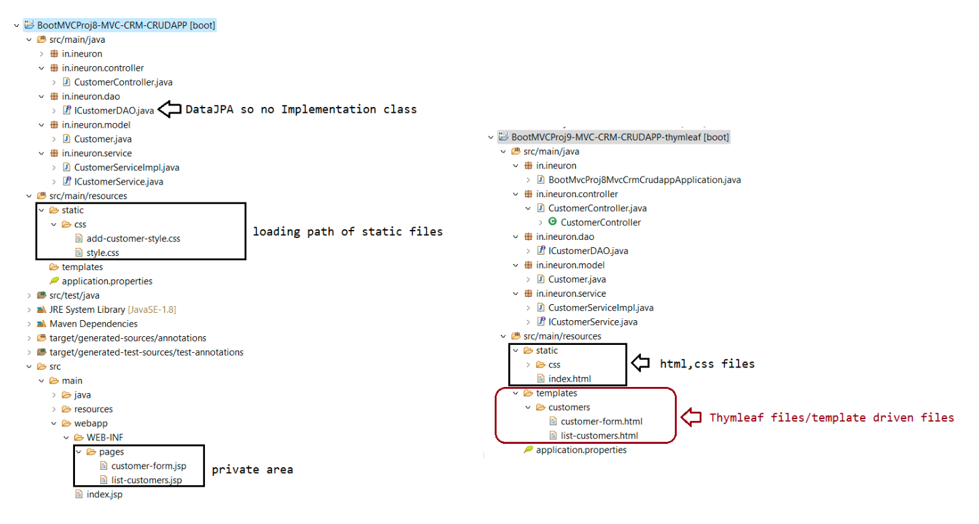

186 SpringRest introduction and Need of JSON

JavaScript Videos :: Uploaded in Resource section[Full Stack Java
Batch]
Revision class of JavaScript on :: Saturday[3.00PM]
========================================================================
Tommo topic :: SpringAOP[Morning 7.00AM]
Link :: https://us06web.zoom.us/j/82753287803
SpringRest and Microservices[Pre-Requisite:: SpringBoot and SpringMVC]
======================================================================
Distrubuted Applications
========================
1. Using java we can develop several types of applications
a. CUI and GUI based applications
b. Web applications
c. Distrubuted applications.
CUI and GUI based applications
==============================
We prefer using J2SE module[CoreJava] of java to build these type of applications
1. CUI => Character User Interface applications
eg: Console based applications[Notepad,calculator,....]
2. GUI => Graphical User Interface applications(Swings, Applets)
eg: Eclipse,Zoom,MS-Office
If we build CUI/GUI applications every user should install these apps in their
machine to use.
Standalone applications are specific to machine.
Web applications
================
applications
We prefer using JEE module(Servlet,JSP) and Spring MVC to build these type of
=> The applications which runs over the internet is called "webapplications".
=> These application no need to download and no need to install.
=> Anybody can access webapps from any location using browser with internet.
eg: Gmail,Facebook,IRCTC etc,...
=> It uses client and server architecture.
=> client (browser) and in server computer we have project.
Note: Main theme is Customer - Buisness communication.
Distrubuted applications
=========================
We prefer using WebServices and RestFulSevices to develop "Distrubuted
applications".
=> The application which is communicating with other applications is called as
"Distrubuted applications".
=> Distrubuted applications are meant for Buisness - Buisness communication.
eg: browser=========> flipart============> paypal ===========>
visa/Master/upi ============> SBI/ICICI
webapps distrubuted distrubuted
distrubuted
payment gateway => visa/master/upi provides world wide infrastructure to perform
cards based transactions.
paypal -> It acts as a brigde between ecommerce site and payment gateway.
The cards issued by visa/master/upi will be given to customer through banks bylinking with bank accounts.
=> We need Distrubuted applications becoz of reusing the buisness process.
usecase 1: Ineuron company----to generate salary slip -------> Excility
global
usecase 2: Ineuron company----to display weather forecast-----> IBM weather
App
usecase 3: Passport App -------> Adhar App
Technologies available to build Distrubuted applications are
a. CORBA
b. RMI
c. EJB
d. Webservices[Soap and XML]
e. RESTFul services(RepresentationStatefull Services)[SpringReST]

187 Difference b w WebServices vs RestFulServices, Implementation of JAX RS and Usage of SpringRest to build RestAPI's, Need of Annotation called @RestController,@Controller,@ResponseBody

SpringRest ====> SpringMVC++
WebApplication ====> Customer 2 Buisness
DistrubutedApplication => Buisness 2 Buisness
eg:: Flipkart,Myntra,Amazon,ineuron,....
Technologies available to build Distrubuted applications are
a. CORBA
b. RMI
c. EJB
d. Webservices
e. RESTFul services(RepresentationStatefull Services)
a. RMI
1. It stands for Remote Method Invocation,It is a part of JDK s/w only given
by SUNMS.
2. It doesnot support Transaction Management,Security,....
3. It is outdated because of EJB.
4. It is language dependent,platform dependent and Architecture dependent.
5. Here the data will be exchanges in the form of binary b/w producer and
consumer apps.
b. EJB
1. It stands for Enterprise Java Beans.
2. It is given by SUNMS
3. Enchanced version of RMI
4. It provides container which will take care of 3rd party services
5. It is langauge dependent(coded only using java)
communication of applications can happen only if the applications are
coded in java only.
6. It fails Interoparability(langague dependancy)
7. Container are heavy weight.
8. They are complex to learn and use.
9. Here the data will be exchanges in the form of binary b/w producer and
consumer apps.
c. CORBA
1. It stands for Common Object Request Broker Architecture.
2. It is a specification which is implemented using IDL(Interface Defnition
Language)
3. Corba is complex to learn and implement.
4. It is architecture and language indepent.
5. Corba looks greate conceptwise,but gives problem towards the
implementation.
To support Interopability Sun MicroSystem released one api called "JAX-RPC".
JAX-RPC(Java API for Xml - Remote Procedural Call) api is built on the
specification of B.P.1.0(WSI organisation)
WSI -> WebServices Interoperability(ideas taken from many organisation and given
the implementation)
B.P.1.0 is successfull, WS-I released B.P.1.1 specification
Note: B.P(stands for Basic Profile)
W.r.t B.P.1.1 specification SUN Microsystem released JAX-WS api(Java api for XML -
WebServices)
We can devleop webservices in 2 ways
a. JAX-RPC(it is outdated becox of xml)
b. JAX-WS(It is good becoz of annotation approach)WebServices
===========
WebServices in java can be developed in 2 ways
a. JAX-RPC(Java API for XML - Remote Procedure calls)
Implementation are
a. Sun Implementation(SI)
b. Apache Axis
c. IBM Websphere
d. Oracle Weblogic etc....
JAX-RPC api follows rules and guideliness provided by B.P.1.0
specification(WS-I => Webservices Interoperability)
b. JAX-WS(Java API For XML - WebServices)
Implementation are
a. Reference Implemenation (RI)
b. Apache Axis2
c. Apache CXF
d. Oracle weblogic
e. IBM Websphere etc...
JAX-WS api follows rules and guideliness provided by B.P.1.1
specification(WS-I => Webservices Interoperability)
If we devleop a webservice using JAX-RPC or JAX-WS then that webservice is called
as "SOAP Based WebService".
SOAP(Simple Object Access Protocol) WebService is called as "Big Services".
RoyFielding identified few problems in B.P.1.1 specification, so SunMicroSystem
released one api called "JAX-RS" api
JAX-RS (Java API For -Restful Services)
a. Jersey implementation(Sun)
b. Rest Easy implementation( JBoss)
WebServices
==========
It is a distrubuted technology which is used to develop distrubuted applications
with Interoperability.
What is Interoperablitiy?
Irrespective of the platform and the Irrespective of the programming language, if
two applications are communicating then those applications are called as
"Interoperable applications".
eg: java -------> python
python -------> .net
.net -------> python
WebServices Architecture
========================
In the world of webservices we have 2 parties
a. Provider => Application which will be providing buisness services to other
applications is called as "Provider application".
b. Consumer => Application which is consuming the services from the other
application is called as "Consumer application".
In the world of webservices always development will begin from provider
side[Producer]
Provider development can be done in 2 waysa. Contract First Approach
b. Contract last Approach
What is Contract?
=> Contract stands for WSDL
=> Web Services Description language
=> WSDL is a special XML which describes how provider is providing buisness
services to consumers.
=> Contract First Approach means WSDL file will be created first then Development
will be started.
=> Contract Last Approach means we will prepare the service first and then WSDL
file will created.
WSDL -> url,input for provider,output for provider,how to access the services will
be documented in the file.
Once provider developement is completed,provider will share WSDL share to consumer
through email,sharepoint,
UDDI(Universal Description Discovery Integration)
Once Consumer gets the WSDL file, we can start consumer development.
Consumer can be developed in below ways
a. Stub based consumer
Based on WSDL if we write some java class we called "Stub Based
consumer".
b. Dynamic Proxy consumer
we send the request.
Dynamically at the runtime some Proxy objects will be created through
Once Consumer development is completed,Consumer will send request to Provider.
Provider will process consumer request and send response to consumer.
refer: webservicesarchitecture.png
Note:Key players when we build webservices
1. Provider
2. WSDL : WebServices Description Language
3. UDDI : Universal Discovery Description Language
4. Consumer
5. SOAP : Simple Object Access Protocol
SOAP based webservices are not really 100% interoperable and adoptable.
SOAP based webservices wont support for JSON/It supports only XML.
SOAP based webservices are not easily adoptable(dependent on XML).
The above mentioned problems are identified by a person called "Roy Fielding".
He compared SOAP webservices with Internet Services(www).
RoyFielding found 5 principles those are called as "REST Architecture principles".
Challenges of SOAP webservices are resolved in RESTFul Services, SOAP is
specification based where as ResTful services are Architecture principles based.
REST Architecture
================
2 Actors are involved here
a. Resource
b. Client
It provides buisness services to other applications.It access buisness services from other applications.
REST COMPONENTS
===============
1. Resource( REST Resource)
2. WADL /Swagger
3. XML/JSON/Text/Yml
4. Client
5. PostMan(To test our application)
=> RoyFielding provided ReST Architecture principle(same prinicple already using by
the internet).
=> SUN Microsystem also supported RoyFielding principle and they released on API
called "JAX-RS".(Java API for XML -RestFulServices)
=> During the invention of this api to market JSON was not available.
=> JSON/XML are language independent and platform independent.
Note: API's are always partial, they contains set of interface and abstract
classes, we can't use api directly to develop a project
we need implementation for API to develop the project.
eg: JDBC API =====> we need implementation jars for JDBC API from db
community like MySQL,Oracle,PostgreSQL,...
Implementation of JAX-RS is "Jersey(SUN),Rest Easy (Jboss)".
Both Jersey and Rest Easy supports for both Rest Resource Devleopment and ReSt
Client Development.
=> We can develop RestFul services using Spring ReSt Module.
=> Spring MVC jars are sufficient to develop RestFul Services (additional jars are
not required).
ReSt Architecture Principles
===========================
1. Unique Address
2. Uniform Constraint interfaces
3. Media Representation
4. Communication Stateless
5. Hateos
What is Unique Address?
Every distrubuted component operation has a unique address.
eg: Every controller will have a unique URL pattern.
What is uniform constratints interfaces?
This principle is given to provide easy adaptablity(without documentation u can
access).
If we use SOAP we need to understand WSDL, which can't be understood by layman,To
resolve this problem we use ReSTful Services.
constraints means limitation(becoz HTTP methods are limited).
To achieve this we need to bind our resource methods with HttpProtocol methods.
eg: @GetMapping ===> for GET request
@PostMapping ===> for POST request
@PutMapping ===> for PUT request
@DeleteMapping ===> for DELETE request
Media Representation====================
The main aim of this priniciple is to provide interoperability(real
interoperability but this is not there is SOAP).
It supports mulitple format of data to exchange.(XML,JSON,...)
RestFul Services will support muliple formats of data to exchange b/w client and
resource.
Communication Stateless
=======================
Client and Resource will interact with each other in stateless manner.
Once the response is reached to the client, that client information will not be
available w.r.t server.
Server should treat every request as the first reqeust only.
Session concpet which is available in webapp's is not required when we build
restapi's.
HATEOS
======
Hypermedia As an Engine for application state.
Server should send response to clients using hyper links.
RestEnd Point URL :: http://www.ineuron/get/CID-100
{
course-id : 'CID-100',
course-name : 'SB & MS',
start-date : '19-jul-2022',
timings : '7.30 to 8.30 AM',
trainer : 'Mr. NaveenReddy',
course-content: 'www.ineuron.ai/get/CID-100/course-content'
}
Note:
1. RestFul Services has no specification, it has only architectural principles.
2. HTTP Request calls => GET,POST,PUT,DELETE
3. Client information should not be stored in RestAPI(B 2 B communication)
Building First ReStful application using SpringBoot + Rest
===========================================================
To build ReST applications
a. Spring WebMVC Module is sufficient no need of any jars
eg: spring-boot-starter-web
a. web app developement using spring mvc
b. rest app development using spring mvc
c. embeded tomcat container
Annotation used here
1. @RestController
It will make our class as "Distrubuted component".
@RestController = @Controller + @ResponseBody
Default value is always Raw Data.
@Controller = It always returns "viewName".
2. write methods in Restcontroller and bind them to Http request method with
unique url pattern.
@GetMapping -> GET request
@PostMapping -> POST request
@PutMapping -> PUT request@DeleteMapping -> Delete request
Configuring below properties in application.properties or application.yml file
server.port=9999 (embeded container will run on 8080 in spring boot)
WishController.java
===================
package in.ineuron.restcontroller;
import java.time.LocalDateTime;
import org.springframework.http.HttpStatus;
import org.springframework.http.ResponseEntity;
import org.springframework.web.bind.annotation.GetMapping;
import org.springframework.web.bind.annotation.RequestMapping;
import org.springframework.web.bind.annotation.RestController;
@RestController
@RequestMapping("/wish")
public class WishController {
@GetMapping("/msg")
public ResponseEntity<String> generateWishMessage() {
LocalDateTime ldt = LocalDateTime.now();
int hour = ldt.getHour();
String body = null;
if (hour < 12)
body = "Good Morning";
else if (hour < 16)
body = "Good Afternoon";
else if (hour < 20)
body = "Good Evening";
else
body = "Good night";
ResponseEntity<String> entity = new ResponseEntity<>(body,
HttpStatus.OK);
return entity;
}
}
EndPoint :: http://localhost:9999/wish/msg
Output :: Good night
Download postman from the following link:: https://www.postman.com/downloads/
Adding postman as plugin for chrome ::
https://chrome.google.com/webstore/detail/postman/fhbjgbiflinjbdggehcddcbncdddomop?
hl=en
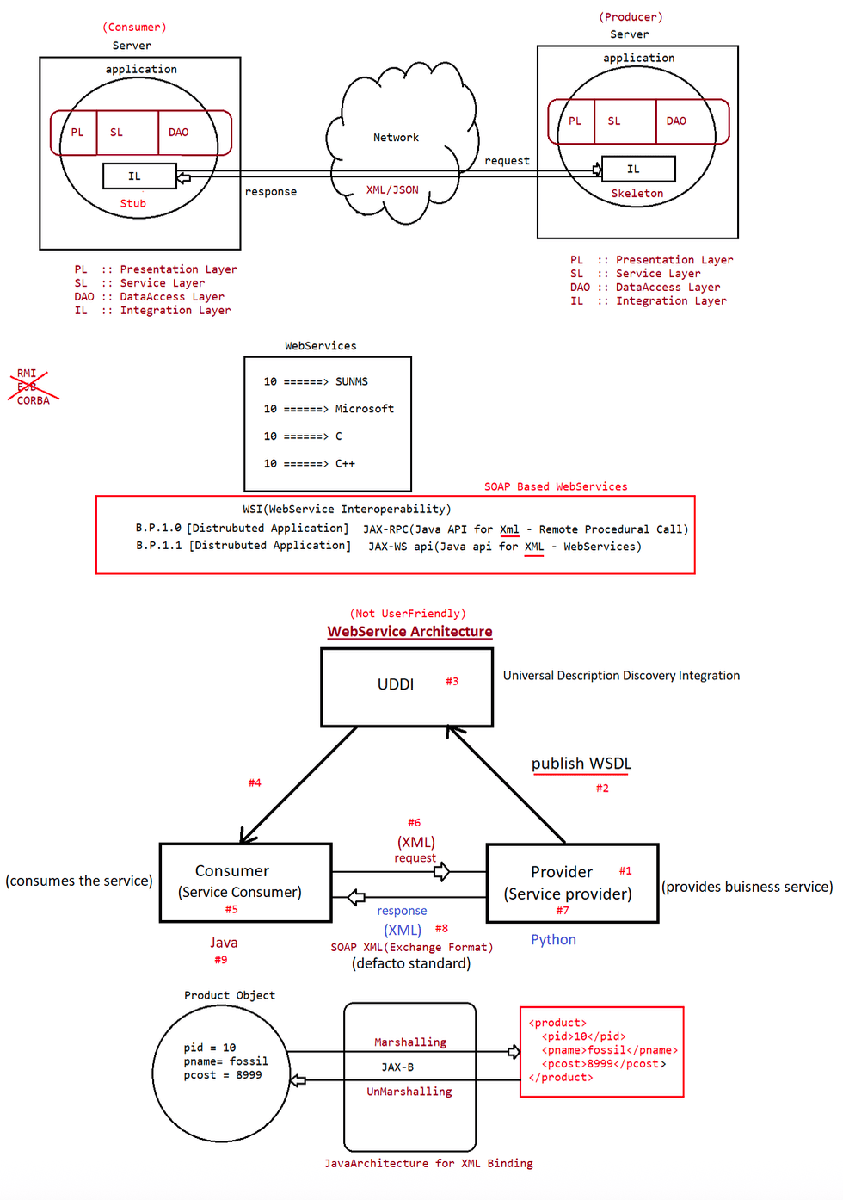
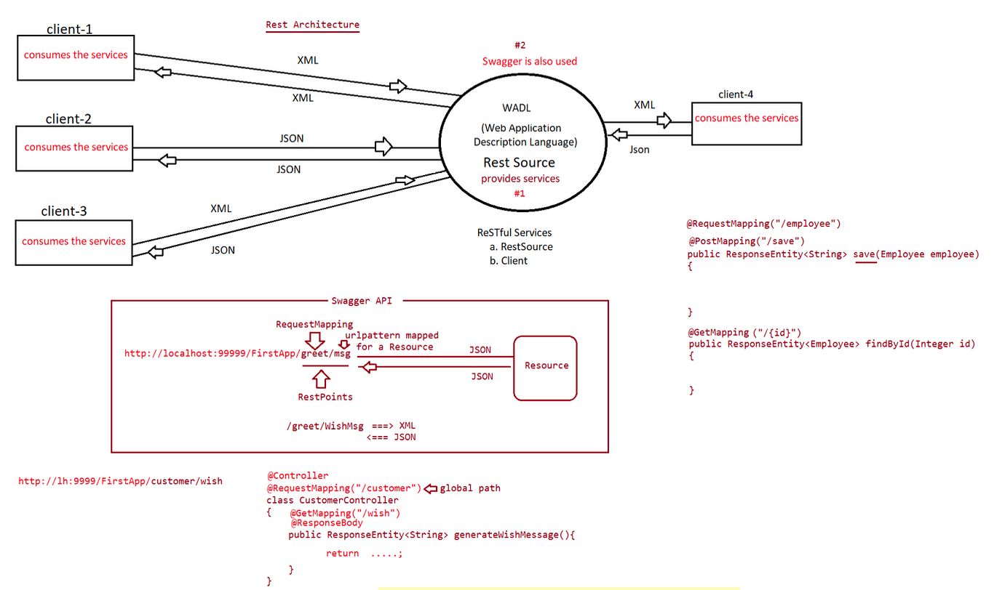
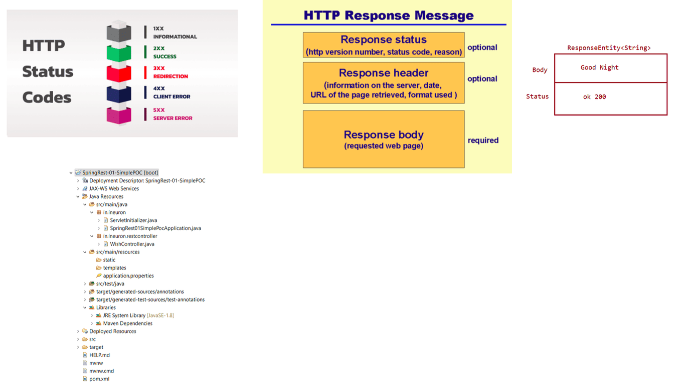

188 spring aop and it's annotations like @Aspect,@Pointcut,@Joinpoint,@Before,@After,@Around,@AfterReturning,@AfterThrowing.
SpringBoot-AOP
=============
To write programs we have 3 styles of coding
a. POP => Procedure Oriented Programming[C]
b. OOPS => Object Oriented Programming[C++,Java,....]
c. AOP => Aspect Oriented Programming[Java,Python,Ruby,....]
Aop =>Cross Cutting Concern
Cutting Concern".
Seperating the Buisness logic from the Service Logic is called "Cross-
CrossCuttingConcern: Move Additional classes of Project into another
classes[Serviceclass/Aspectclass] and bind
when and where they are required.
1. Aspect => It is a class that provides additional services to project.
TransactionManagement,Security,Encode/Decode,Logging,...
2. Advice => It is a method inside Aspect class/It is acutal implementation of
Aspect.
Every Advice must be connected to Type.
Types of Advices
a. Before Advice => Executing Advice before calling methods
execution order :: adviceMethod ----- 1st
b.method ----- 2nd
b. After Advice => Executing Advice after b.methods finished
execution order :: b.method ----- 1st
adviceMethod ----- 2nd
c. Around Advice => Advice code divided into 2 methods
First part executed before advice and then
b.method, later 2nd part of Advice.
execution order :: adviceMethod ---- 1st part
b.method
advicemethod ----- 2nd part
Advice.
d. After Returning Advice => After executing b.method only on success execute
execution order :: b.method ----- 1st
(Is b.method executed succesfully,No Exception then
call Advice)
e. After Throwing Advice => After executing b.method if b.method is throwing
any exception then execute Advice.
execution order :: b.method ----- 1st
(Is b.method not executed succesfully,Exception
occured) then
call adviceMethod() --- 2nd
3. PointCut => It is a expression that will select buisness methods which needs
Advices,It can never specify what advices.
expression :: Access_Specifier ReturnType
packagename.classname.methodname (paramname)
4. JoinPoint => It is a combination of Advice + PointCut. In simple wordsConnecting Buisness Methods with the required Advices.
5. Target => Pure Buisness class Object.
6. Weaving => It is a process of mixing buisness class methods and there connected
advices.
7. Proxy => Final output(class/object) is called as "Proxy" that contains both
logics connected.
What is the difference b/w @After, @AfterReturning and @AfterThrowing Advices?
After Advices is executed next to buisness method either success or failure.
AfterReturning Advices is executed next to buisness method only if there is not
exception.
AfterThrowing Advices is executed next to buisness method only if there is a
exception.
Implementation of the above can be done in 2 ways
=================================================
1. Spring AOP using XML Based Configuration[Legacy Style]
2. Spring AOP using AspectJ(Pure Annotations)
<dependency>
<groupId>org.springframework.boot</groupId>
<artifactId>spring-boot-starter-aop</artifactId>
</dependency>
3. Annotations used are
a. @Aspect
b. @Before
c. @After
d. @Around
e. @AfterReturning
f. @AfterThrowing
g. @PointCut
refer:: Spring-AOP-AspectJApp
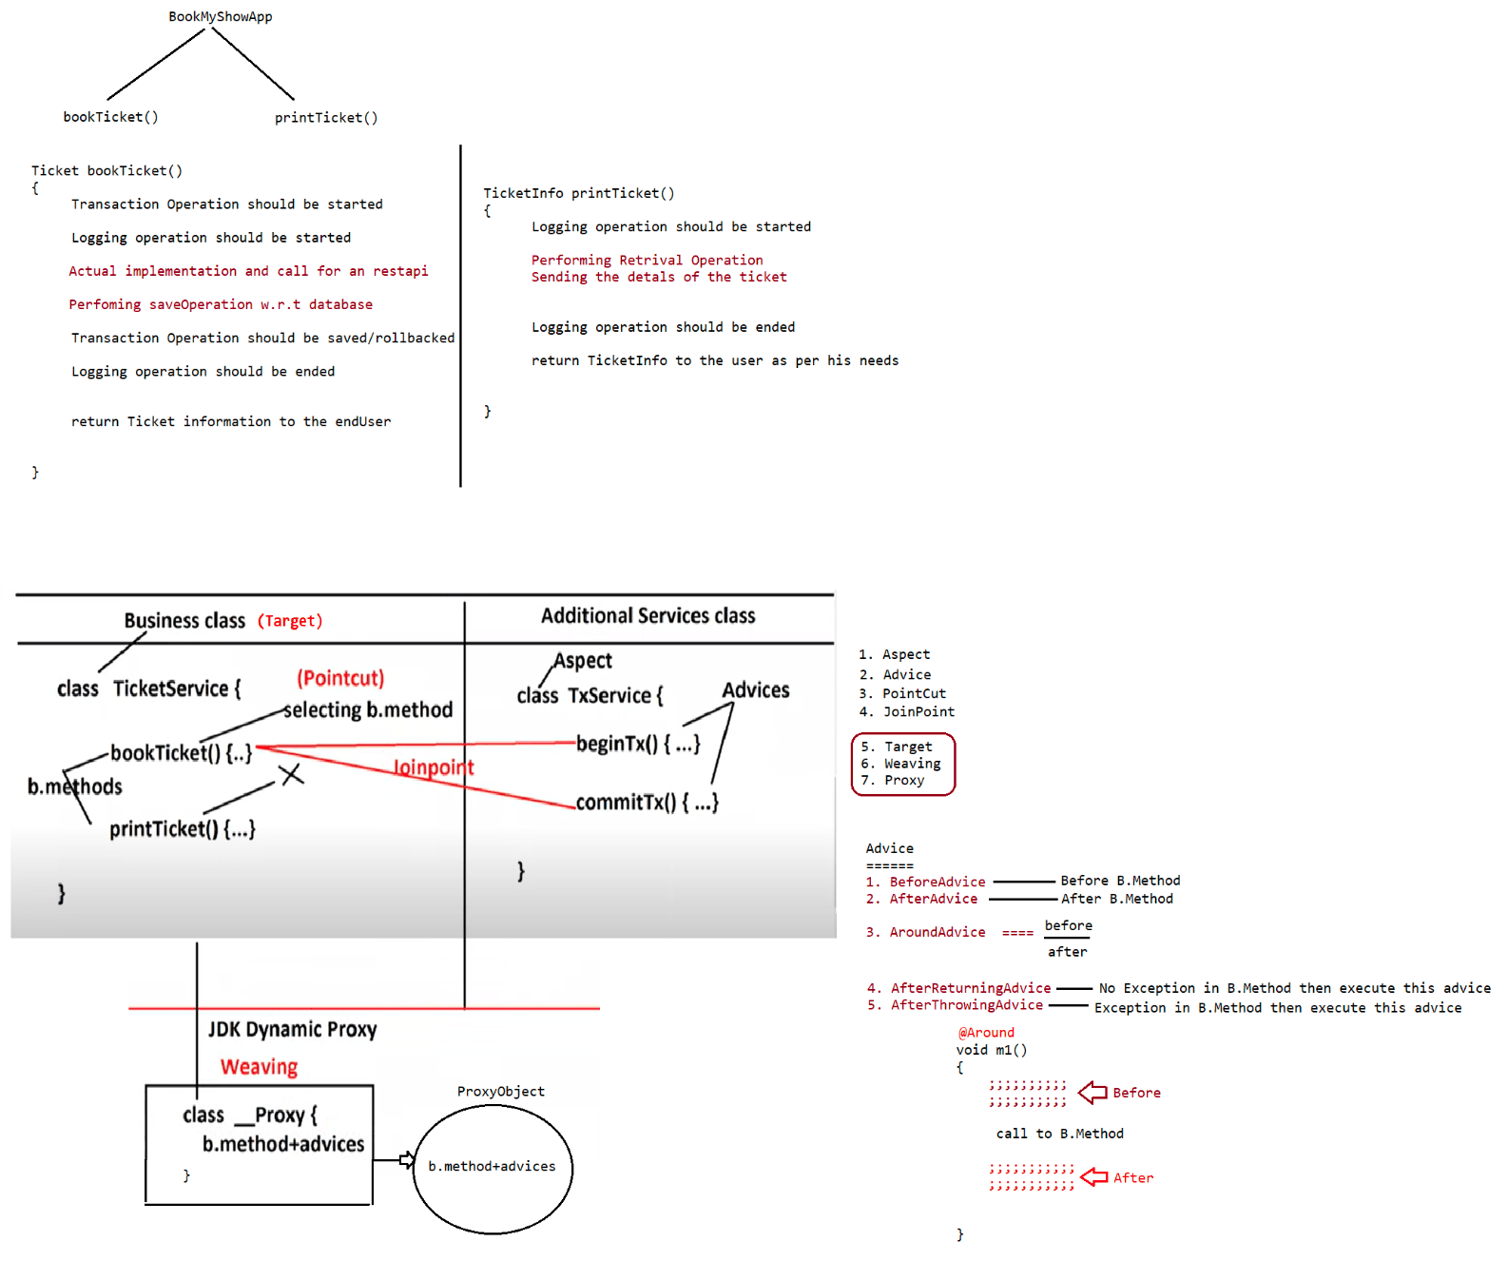
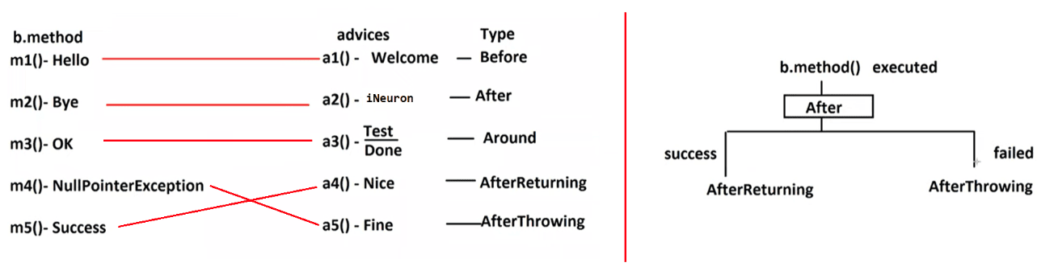

189 SpringRest,Usage of Postman tool to send GET,POST,PUT,DELETE request, Usage of @RequestParam,@PathVariable and its difference

SpringRest ===> SpringMVC++
=============================
Note:: @RestController ===> @Controller + @ResponseBody
ResponseEntity<T>(return type of handler methods) indicates that the genereated
output should directly go via DispatcherServlet
to the RestClient.
ResponseEntity<String> as the return type of handler method / String as the return
type of the handler methods indicates that in the Response
body the content-type = "text/plain".
RestFulServices
===============
1. RestResource
2. RestClient
What is RestResource?
It is a distrubuted component which provides buisness services to other
applications over the network.
What is RestClient?
RestClient can be human being who can send the HttpRequest.
RestClient can be Postman,Soapui,or any UIComponent.
Note: Writing url pattern at the method level is optional
1. If we dont write url pattern for a particular request type then default
will taken
eg:
@GetMapping
public String welcomeMessage() {
String msg = "Welcome to Restful Services from Ineuron...";
return msg;
}
2. If we have 2 methods with no url pattern then we need to have a url pattern
which is compulsory
@GetMapping("/welcome")
public String welcomeMessage() {
String msg = "Welcome to Restful Services from Ineuron...";
return msg;
}
@GetMapping("/greet")
public String greet() {
String msg = "Good Afternoon";
return msg;
}
3. It is always recomended to write both class level and method level url
pattern through which we can achieve unique url pattern and avoid
ambiguity problems.
HttpMethods
1.GET -----> Selecting a Record from Database(Read operation)
2.POST ----> For Creating a Record(Insert Operation)
3.PUT ----> For Updating a Record(Update Operation)4.DELETE --> For Deleting a Record(Delete Operation)
5.PATCH --> For Updating a Record(Update Operation)
6.TRACE
7.HEAD
8.OPTIONS
Note:: PUT for Complete updation/modification of Record.
PATCH for Partial modification of Record.
eg::
@PutMapping("/employee")
public <RT> updateEmployee(Employee emp){
}
@PatchMapping("/employee")
public <RT> updateEmployeeByEmail(String email){
}
HEAD Request mode HttpResponse does not contain body/output/results so it can't be
used for Read/Select Operation.
TRACE Request mode is given to trace/debug components involved for SUCCESS or
FAILURE of request processing.
It can't be used for CRUD operation.
OPTIONS Mode request gives the possible HttpRequest methods/modes that can be used
to generate the request to webcomponents. Its HttpResponse
purely contains ListModes/methods that are possible to give the request to
webcomponents.
eg#1.
@WebServlet("/test")
public class TestServlet{
public void doGet(request,response){
}
}
response as
If we give options mode as the request to this webcomponent, then we will get the
Allow :: GET,HEAD,OPTIONS
eg#2.
@WebServlet("/test")
public class TestServlet{
public void doPost(request,response){
}
}
response as
If we give options mode as the request to this webcomponent, then we will get the
Allow :: POST,OPTIONS
a. GET -> It is used to get a data from the Database.
It is called as Idempotent Request that is even if we send the request
multiple times the output won't change.When should i bind method to Http GET?
If the client is sending the request to get some information from the resource
then we need to use GET.
eg: client wants to get the product data based on id.
client wants to get the bookInfo based on id.
client wants to get the Employee data based on id.
To send the request along with the data we need to use
a. Query parameter
@RequestParam("variableName") it is mandatory to send it through
url pattern
//http://localhost:9999/welcome/msg?id=10&name=sachin
eg:@GetMapping("/msg")
public ResponseEntity<String> greetMessage(@RequestParam("id") Integer
id, @RequestParam("name") String name) {
}
The data will go to the server in the form of String,but the data gets
converted to respective type by Dispatcher Servlet during
PreProcessing phase using filters.
Note: @Query Paramter can be made as optional in SpringMVC and also in
SpringRest
//http://localhost:9999/welcome/msg?id=10&name=sachin
@GetMapping("/msg")
public ResponseEntity<String> greetMessage(@RequestParam(value =
"id", required = false) Integer id,
@RequestParam("name") String
name) {
}
we can send multiple query parameters through a seperation called
"&".
b. Path parameter
They are called as "URI Paramteres".
They are used to send the data from client to server in the URL
eg: www.ineuron.in/course/{nitin}/{springboot}
Path parameters can be in anywhere in the url, where as Query paramters
should be at the end of the URL.
eg: www.ineuron.in/course/{nitin}/java/{springboot}
To use PathVariables in RestController we use "@PathVariable".
eg: @RestController
@RequestMapping("/welcome")
public class WelcomeController {
//http://localhost:9999/welcome/msg/10/sachin
@GetMapping("/msg/{id}/{name}")
public ResponseEntity<String> greetMessage(@PathVariable
Integer id, @PathVariable String name) {
}
}
Note: 1. We can have 1 path parameter
eg: @GetMapping("/msg/{name}")2. We can have 2 path parameter
eg:@GetMapping("/msg/{id}/{name}")
3. We can have path parameter in between also.
eg:@GetMapping("/msg/{id}/course/{name})
Note:
@RequestParam -> In Spring framework to hold query
parameters(http://localhost:9999/test?name=sachin&courseId=10)
@PathVariable -> In Spring framework to send the data from client to server
(/name/{courseId})
@PathParam -> This annotation is not from SpringFramework,it is from JAX-RS.
Difference b/w QueryParameter and PathParameter?
QueryParameter
a. It is used to send the data from client to server in the URL
b. It represents the data in key value pair(K=V)
c. It should always be at the end, starts with ? and seperated with &
d. It will be collected in the RestController through @RequestParam,it can be
made optional using required=false
PathParameter
a. It is used to send the data from client to server in the URL.
b. It does not represents the data in the key value pair(/url/{variable}).
c. It need not to be always at the end,it can be anywhere.
d. It will be collected in the RestController through @PathVariable,it is
compulsory always.
Case1::
@GetMapping("/info/{id}/JRTP/{name}")
URI :: course/info/5/JRTP/navinreddy/telusko/microservices
Output:: 404 Error
Case2::
@GetMapping("/info/{id}/JRTP/{name}")
public ResponseEntity<String> getCourseDetails(
@PathVariable Integer id,
@PathVariable String name) {
;;;;;;;
}
URI :: course/info/navinReddy/JRTP/5
Output:: MethodArgumentTypeMismatchException
Case3::
@GetMapping("/info/{id}/JRTP/{name}")
public ResponseEntity<String> getCourseDetails(
@PathVariable String id,
@PathVariable String name) {
;;;;;;;
}
URI :: course/info/navinReddy/JRTP/5
Output:: Success(not always, it might disturb the logic)
